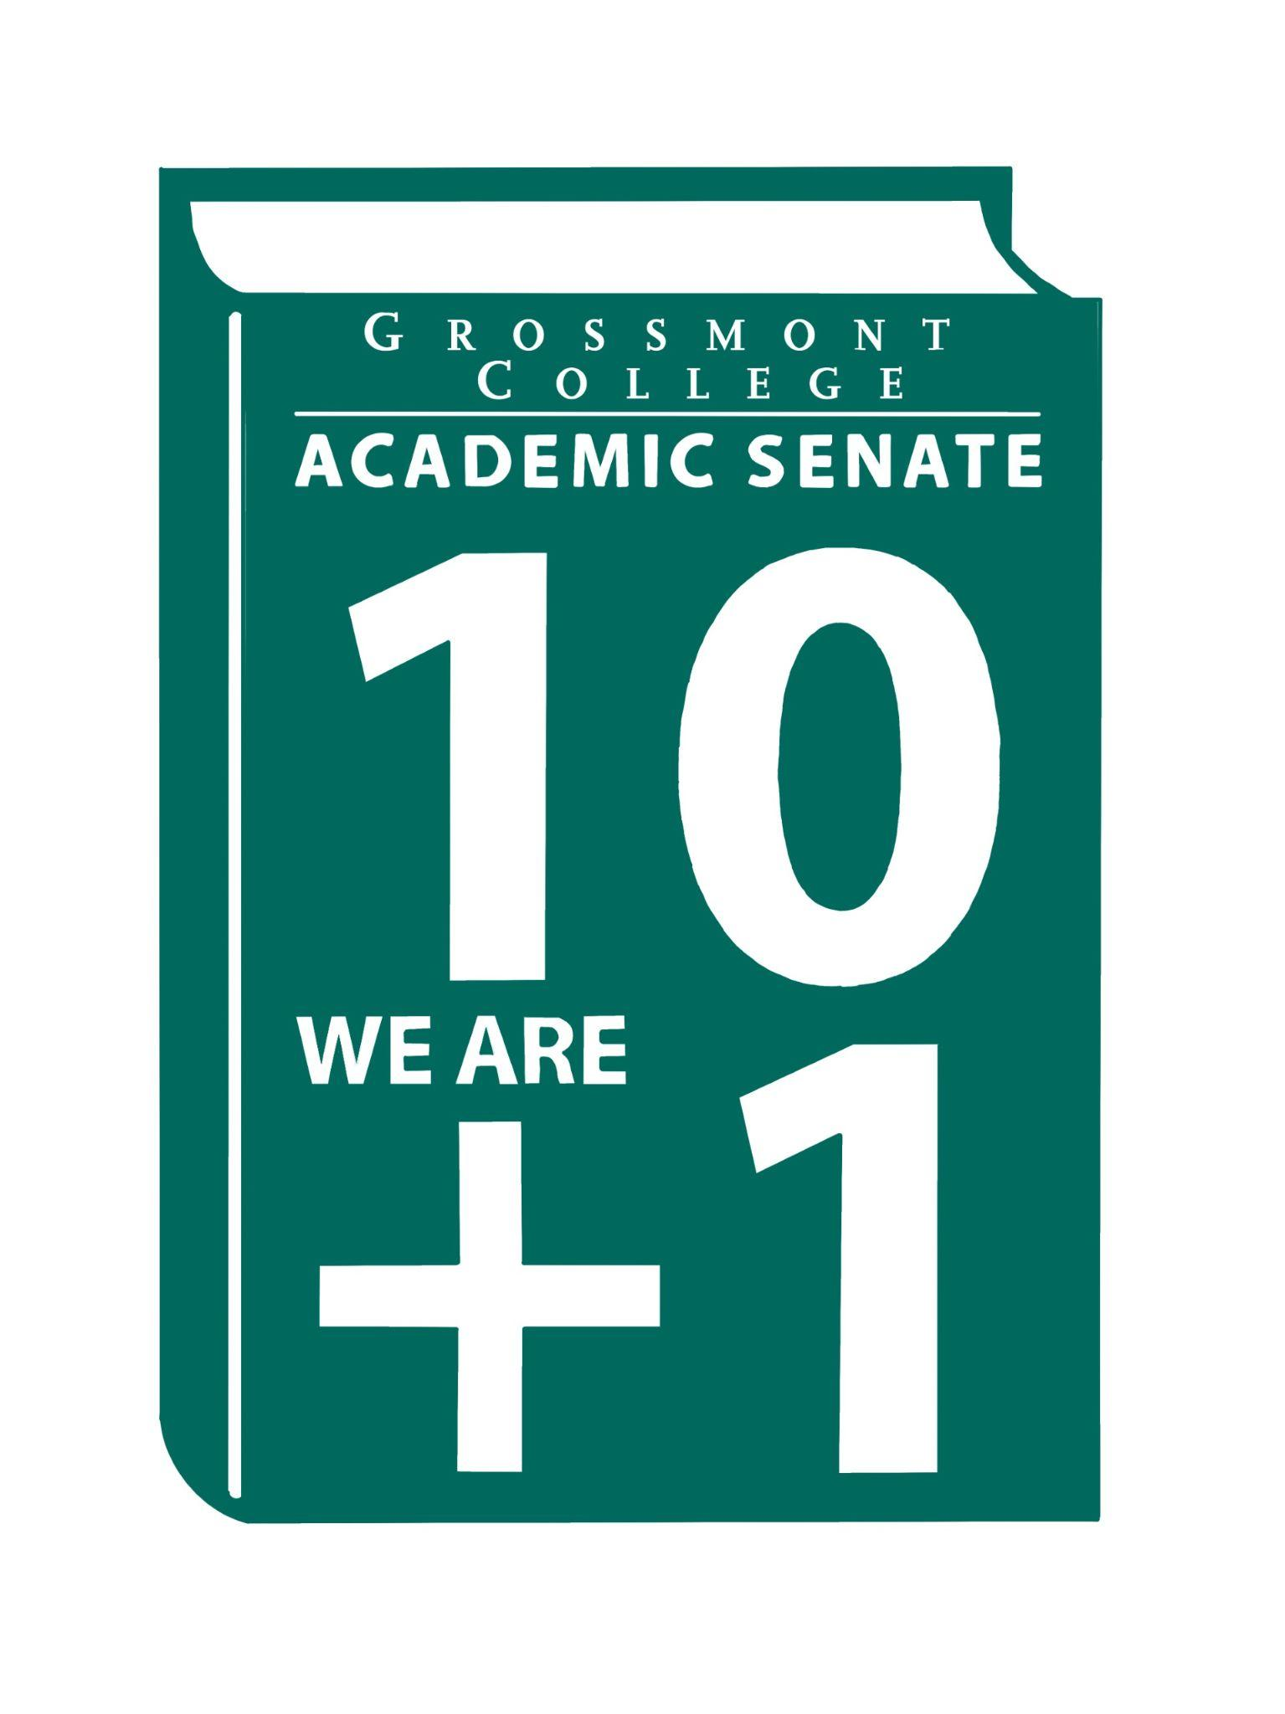  10 + 1  Title 5 §53200(b): Academic Senate means an organization whose primary function is to make recommendations with respect to academic and professional matters. In Sections 53200(c),  "Academic and professional matters" means the following policy development and implementation matters:  (1) curriculum, including establishing prerequisites and placing courses within disciplines;  (2) degree and certificate requirements;  (3) grading policies;  (4) educational program development;  (5) standards or policies regarding student preparation and success;  (6) district and college governance structures, as related to faculty roles;  (7) faculty roles and involvement in accreditation processes, including self-study and annual reports;  (8) policies for faculty professional development activities;  (9) processes for program review;  (10) processes for institutional planning and budget development; and  (11) other academic and professional matters as are mutually agreed upon between the governing board and the academic senate  District/College is to “rely primarily upon the advice and judgment”  (5 CCR 53200(d)) Of the A.S. in the following areas:  COLLEGE MISSION STATEMENT  MISSION  Grossmont College serves the diverse population of our surrounding community and beyond by creating clear and accessible pathways to degrees and careers that lead to social and economic mobility for our students. We work collaboratively to cultivate an equitable student-centered learning environment, and we hold ourselves accountable for improving student outcomes through ongoing assessment, evaluation, and data-informed decision-making. Grossmont.  PROCESSES FOR  COLLEGIAL CONSULTATION  (5 CCR 53200(d) & GCCCD AP 2510)  *The Board will Rely Primarily Upon  the Academic Senate  **The Board will seek Mutual  Agreement with the Academic Senate. |   Academic Senate Agenda  Monday, June 1, 2026  11:00 am–12:20 pm  Room 26-220  ATTACHMENTS  - Call to Order - 11:00 AM  - Public Comment—Persons wishing to address the Senate will be given a maximum of 4 minutes to address the Senate about a non-agendized item or items, with a maximum of 15 minutes allowed for public comment. The Senate may vote to extend public comment at any meeting. If you wish to speak during public comment, please complete the attached form by Thursday, within 72 hours of the scheduled academic senate meeting. The Senate will still welcome public comment on the scheduled meeting day, and it may continue at the end of the meeting if necessary.  - Approval of minutes (5/18/2026) (2 min)  - Approval of Agenda (2 min)  - Announcements  5.1 Please attend the graduation ceremony (6.4.26 @ SDSU)  5.2 Congratulations to Fellow Faculty Colleagues Recognized @ the College Ceremony on 5.14.26  5.3 Thank you, Natalye Harpin (Interim AS Vice-President)  5.4 Congratulations, Gary Jacobson - Emeritus Status; Retirements - Ray Funk, Donna Dixon & Sosha Thomas; embarking on a new journey - celebrating Katy Banville & Rie Hazel.  5.5 Celebration of New/Newer Faculty  5.6 Academic Senate Volunteer Opportunities  6. President’s Report (10 min)  6.1 End of Year Report - Accomplishments Highlights/In Progress/Path Forward  6.2 Breaking the Cycle of Silence - Stepping Up & Speaking Up for colleagues (Pending SOC review)  6.3 Survey-Gathering Data to assess and improve communication from the Senate to the broader Collective (Pending SOC review)  7. Information Items: Updates and information are presented for discussion and feedback, including the introduction of items that will need constituency feedback and a vote of approval or endorsement at the next meeting.  7.1 Feasibility Policy/Process (2nd read)  7.2 MOU Process (Developed by AO/Curriculum Chair & Transfer Center Specialist in collaboration w/ CC- 2nd read)  8. Presentations  8.1 Dr. Perla Lopez - Budget Committee (Revised Rubric)  8.2 Faculty Representatives Reports  - Senate Committees  - Participatory Governance Committees  - Facilities/Budget/PIEC/FPSC  - EEOAC (Update-District)  - TPPG (Update-District)  9. Action Items  9.1 Resolution in Support of Pan-African Virtual College  9.2 MOU Process  9.3 MOU National University  10. Vice-President’s Report/Unfinished Business  10.1 Participatory Governance (open active recruitments)  10.2 Senators (Updating dept./division reps, specifically counseling)  11. Future Agenda Items  11.1 AS Voting Process-Board Docs Update (New Vendor being explored by the District)  11.2 Academic Senate Action Item Voting Process  11.3 Participatory Governance Committee Members Roster Update  12. ASCCC Webinars, Announcements, and Resources  June 11-13  - 2026 Faculty Leadership Institute (Registration Link)  - Registration Deadline: June 3, at 5:00 pm  June 15  Mentor applications open for the 2026 Faculty Empowerment and Leadership Academy (FELA)! For further details on program requirements, please visit the Faculty Empowerment and Leadership Academy page on our website.  September 22–25,  2026, Collective Equity Impact (CEI) Institute, in Anaheim, CA.  Collective Equity Impact Institute.com  13. Adjournment – Next meeting 8/20/2026 AS Joint Retreat

