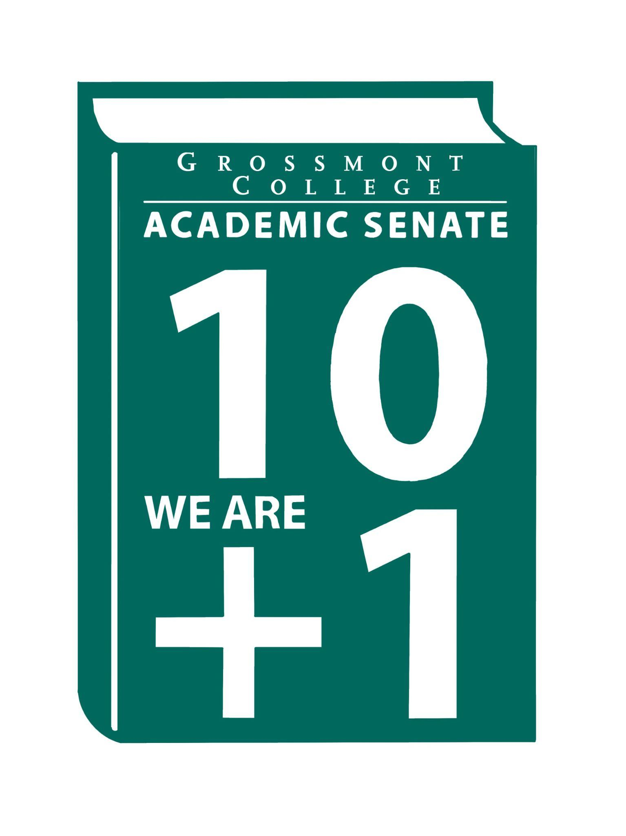  10 + 1  Title 5 §53200(b): Academic Senate means an organization whose primary function is to make recommendations with respect to academic and professional matters. In Sections 53200(c),  "Academic and professional matters" means the following policy development and implementation matters:  (1) curriculum, including establishing prerequisites and placing courses within disciplines;  (2) degree and certificate requirements;  (3) grading policies;  (4) educational program development;  (5) standards or policies regarding student preparation and success;  (6) district and college governance structures, as related to faculty roles;  (7) faculty roles and involvement in accreditation processes, including self-study and annual reports;  (8) policies for faculty professional development activities;  (9) processes for program review;  (10) processes for institutional planning and budget development; and  (11) other academic and professional matters as are mutually agreed upon between the governing board and the academic senate  District/College is to “rely primarily upon the advice and judgment”  (5 CCR 53200(d)) Of the A.S. in the following areas:  COLLEGE MISSION STATEMENT  MISSION  Grossmont College serves the diverse population of our surrounding community and beyond by creating clear and accessible pathways to degrees and careers that lead to social and economic mobility for our students. We work collaboratively to cultivate an equitable student-centered learning environment, and we hold ourselves accountable for improving student outcomes through ongoing assessment, evaluation, and data-informed decision-making. Grossmont.  PROCESSES FOR  COLLEGIAL CONSULTATION  (5 CCR 53200(d) & GCCCD AP 2510)  *The Board will Rely Primarily Upon  the Academic Senate  **The Board will seek Mutual  Agreement with the Academic Senate. |   Academic Senate Agenda  Monday, April 6, 2026  11:00 am–12:20 pm  Griffin Gate  ATTACHMENTS  - Call to Order - 11:00 AM  - Public Comment—Persons wishing to address the Senate will be given a maximum of 4 minutes to address the Senate about a non-agendized item or items, with a maximum of 15 minutes allowed for public comment. The Senate may vote to extend public comment at any meeting. If you wish to speak during public comment, please complete the attached form by Thursday, within 72 hours of the scheduled academic senate meeting. The Senate will still welcome public comment on the scheduled meeting day, and it may continue at the end of the meeting if necessary.  - Approval of minutes (3/16/2026) (2 min)  - Approval of Agenda (2 min)  - Announcements  5.1 Call-out for volunteers to serve on the Participatory Governance Committees (deadline to apply 4-23-26)  5.2 Arab Heritage Month (Please see calendar of events)  5.3 Americans and the Holocaust traveling exhibition coming to Grossmont College Library (4-14-26 thru 5-21-26)  5.4 2026 Graduation Ceremony (Distinguished Faculty Presentation-Removed)  5.5 Griffin Grind is open for business (the old Java Market) in Building 60)  6. President’s Report (10 min)  6.1 Districts Accessibility Plan  6.2 Spring Plenary Resolutions (Please review -Plenary is 4/9/26)  6.3 Participatory Governance Guidelines (Roles and Responsibilities)  6.4 Human Resources Advisory Council (HRAC): AP/BPs AP 7180: Employee Residency  7. Information Items: Updates and information are presented for discussion and feedback, including the introduction of items that will need constituency feedback and a vote of approval or endorsement at the next meeting.  7.1 Draft of District MOU Approval & Implementation Process  7.2 Recommended Process to review the Senate's Constitution & Bylaws  7.3 Academic Senate Action Item Voting Process  7.4 BP 4035 Controversial Issues (Please Review)  7.5 AP/BP 4230 Grading and Academic Symbols (Please Review)  7.6 AP 4222-Pre-Collegiate Basic Skills Coursework (Please Review)  7.7 AP/BP- 3775 AI Policy (Please Review)  8. Presentations  8.1 Professional Advancement Committee (Academic Rankings)  8.2 Accreditation Findings Review (Accreditation Taskforce)  8.3 PIEC: Student Survey (Malia & Tate)  8.4 Faculty Representatives Reports  - Senate Committees  - Participatory Governance Committees-  - Facilities/Budget/PIEC/FPSC  - EEOAC (Update-District)  - TPPG (Update-District)  9. Action Items  9.1 GC Constitution & Bylaws (Revised)  10. Vice-President’s Report/Unfinished Business  10.1 Participatory Governance (open active recruitments)  10.2 Senators (Updating dept/division reps, specifically counseling)  11. Future Agenda Items  11.1 AI Taskforce  11.2 CPL Update  11.3 College President’s Forum-tentative  12. ASCCC Webinars, Announcements, and Resources  - Common Course Numbering (CCN) Office Hours  Wednesday, April 1, 2-3:00 pm  Monday, April 27, 1-2:00 pm  - The Academic Freedom Resource Guide is intended to support faculty with information to ensure they know their roles, rights, and responsibilities in the use of academic freedom; it includes links to a Playlab.ai bot trained to support research on academic freedom  13. Adjournment – Next meeting 4/20/26

