

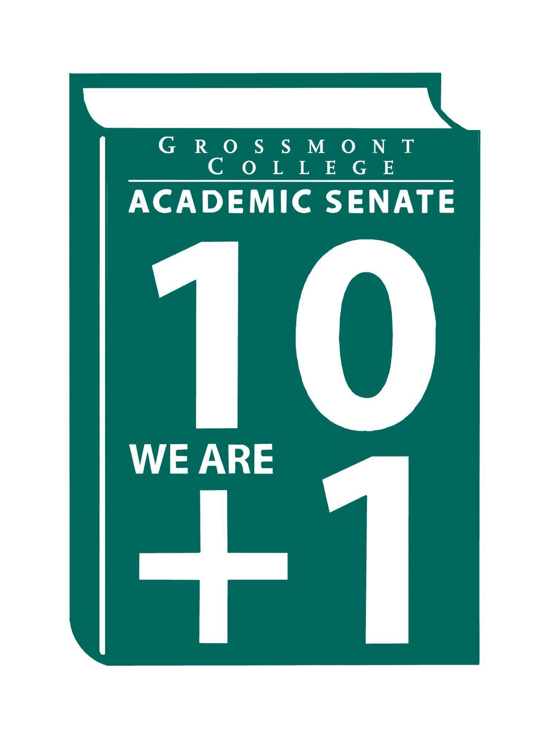

Meeting Minutes of the Academic Senate
Grossmont College
November 17, 2025
11:00 am-12:20 pm
ATTACHMENTS
1 | Call to Order 11:05 am
2 | Public Comment:  Victor A. - Asked for support for Ethics Bowls December 6th, Judges needed! 45 total judges is the goal.
3 | Approval of minutes from November 3, 2025.  VOTE: Minutes approved with no objections  Motion: J. Calo/J. Waller
4 | Approval of Agenda  VOTE: Agenda approved with no objections  Motion: J. Calo/J. Waller
5  5.1  5.2  5.3  5.4 | Announcements  ADSOC Agenda request (document in the attachment folder)  ADSOC agenda is accessible in the attachment folder for input from the collective AS.  Faculty Hiring Committees-Volunteers needed (Biology, CSIS, ESL & Career Counselor)  The last day to submit the interest form to volunteer to serve on the hiring committee is this week.  FPDC-Flex Week Proposals (Deadline 11/18/25)  The FPDC committee is seeking presenters for Flex Week. Detailed information is noted in the recent announcement from FPDC.  THRIVE Event ( Faculty Representative are needed to present information on Participatory Governance, Senates & Union 11/19/25 12-1pm)  If interested, the event will be held from 12:00-1:00pm to the library Living Room.
6  6.1  6.2  6.3  6.4 | President’s Report  Human Resources Council Update (AP 2710 Follow-up response VCHR)  Language was proposed for follow-up, recommending that the conflict-of-interest wording be removed from the requirements for individuals seeking outside employment.  ASCCC Resolutions (2025 Fall Plenary-Review Packet in attachment folder)  Requested that the State Chancellor’s Office develop a protocol on academic freedom and social media threats as a result of our colleagues at GC. Vote by acclamation did not pass because of the wording. ASCCC will be working with colleges to create a consistent policy regarding academic freedom and social media rights. The resolution was passed by 98%.  CPL-Notice of Proposed Rulemaking (California Code of Regulations, Title 5, CPL & HS Course Articulation)  Credit for Prior Learning information has been posted by the Board of Governors. A 45-day notice period is required for the proposed rulemaking. Comments and recommendations are welcomed.  Chairs/Coordinators Mtg & SOC-Follow-up discussion on Minimum Qualifications (MQs) & Equivalency on the CORs.  Dee Aceves-Curriculum Chair presented information regarding the mandate to include MQs on CORs at the Chairs & Coordinators & SOC meetings. Since the matter is 10+1 faculty primacy, the Curriculum committee will be the lead in compiling data and develop a process for a best path forward.  As an example, of the 10+1 faculty primacy on MQs & Equivalency, HR sent a request for the evaluation of the equivalency for a Cuyamaca Engineering faculty position. A copy of the document is accessible in attachments.
7  7.1  7.2  7.3  7.4 | Information Items  Resolution Affirming 10+1 Primacy (1st Read)  Follow-up was requested regarding the drafting of a resolution affirming 10+1 primacy. Members are asked to take this item back to their respective departments for review.  Resolution (ASGC)-Ensuring Precalculus Choice at Grossmont College after AB 1705 (1st Read)  Vi Huynh, ASGC President provided an update on the AB 1705 document. He highlighted the need for lower-level math courses to support student success, particularly for veterans. Concerns were raised regarding the limited availability of these lower-level math options. A comment was raised noting that SDSU offers lower-level math courses that Grossmont College does not. Since an updated version of the resolution was provided during the meeting the matter will be re-reviewed as a 1st read at the next Senate meeting.  5.3.3.1 AFT Contract recommended language (1st Read)  Concerns were raised regarding the implementation of key items with contractual language. Based on this feedback and with support from AFT, the language was revised. This draft document is presented for collective feedback before it is forwarded to AFT.  BP 5031 & Memorandum Empowering Day-One Access through OER (Title 5, § 54221- Burden-Free Access to Materials  Day-One access for OER was discussed. The timeline was reviewed, and the due date is January 26, 2026. The Associate Vice Chancellor (ASV) added this as an agenda item at the ESS Committee, noting that the matter falls under 10+1 primacy. The OER committee will take the lead in reviewing the matter and develop a process for a best path forward. The ASV wrote BP 5031, however, the matter will remain under faculty jurisdiction with collaboration from the District.
8  8.1  8.2  8.3 | Presentations  Facilities Representatives Reports-(Senate & Participatory Governance Committees)  PIEC (Malia M.)-The discussion focused on the Key Performance Indicators (KPIs) listed on the website. The group reviewed how the current KPIs align with SCFF, accreditation standards, and the overall campus vision. Work is underway to articulate guiding principles for KPIs should revisions be needed. The question of how to measure belonging was also addressed, noting that this is evaluated through research and by examining factors such as student access to resources.  - College Council (Jeff W.)-Explained the need for a public comment period to allow members of the public to provide input.  - Budget Committee-Updated report @ the next meeting  - PD Committee-Updated report @ the next meeting  - Technology Committee-Updated report @ the next meeting  A request was made by a Senator to have Participatory Governance Committees update the website with timely posts of the minutes and agenda.  It was noted that faculty can attend meetings to express their concerns and have requests/inquiries agendized via the faculty representatives serving on the respective committees.  Robert Henry-History Department (Narrative & Remembrance)  The History Department continues its series connecting current events with related historical moments. Professor Henry will present on the often-overlooked Rock Springs Massacre on its 140th anniversary. Join us on Tuesday, December 2, from 2:00–4:00pm in Griffin Gate as he shares his experiences visiting Rock Springs and engaging with local residents.  Vi Huyng-ASGC President (Joint Resolution-AB 1705)-presented during discussion of the resolution.
9  9.1  9.2 | Action Items-  Faculty Protocol: Responding to Social Media Harassment and Threats Targeting Faculty on Academic Freedom  Motion J. Waller/S. Working  Motion passes  Academic Senate One-Year Vision-Tabled
10  10.1  10.2 | Vice-President’s Report/Unfinished Business-Tabled  Participatory Governance  Senators (Request for updated dept/division reps)
11  11.1  11.2  11.3 | Future Agenda Items  Evan Wiring & Michael Stewart-CPL-Tabled  New/Newer Employee Welcome Reception  Proposal to resume Faculty Mediation
12 | Adjournment:  VOTE: Motion to adjourn: K. Caires/L. Braff  The meeting adjourned at 12:20.  Next meeting: December 1, 2025.
SIGN IN

11/17/2025 10:54:28 | Patrice Braswell | Senator | A.R.C.
11/17/2025 10:54:53 | Dylan Wells | Senator | English, adjunct faculty
11/17/2025 10:55:13 | Michele Perchez | Senator | Biology
11/17/2025 10:56:49 | Sébastien Cormier | Senator | Physics and astronomy
11/17/2025 10:57:52 | Jamie Gould | Senator | ASL
11/17/2025 10:58:07 | Ryan Gray | Senator | VAH
11/17/2025 10:58:08 | Adam Deutsch | Senate Officer (Only SOC) | English/ESBS
11/17/2025 10:58:37 | Kathleen Banville | Senator | Kathleen.banville@gcccd.edu
11/17/2025 10:59:35 | Randy Abshier | Senator | ESNH
11/17/2025 10:59:51 | Felicia Kalker | Senator | Library
11/17/2025 10:59:57 | Patricia Chow | Senator | CTE/Business
11/17/2025 11:00:10 | Carey Flores | Senator | Respiratory therapy
11/17/2025 11:00:10 | Jenny vanden Eynden | Senator | Mathematics
11/17/2025 11:00:24 | Martin Larter | Senator | Chemistry
11/17/2025 11:01:05 | Robin Sepúlveda | Senator | CDEFS
11/17/2025 11:01:52 | James Holden | Senator | Biology
11/17/2025 11:02:07 | James foran | Senator | CTE Culinary
11/17/2025 11:02:27 | Dr. Vanessa Fountain | Guest | ALC
11/17/2025 11:02:28 | Susan Working | Senator | Math
11/17/2025 11:02:38 | Brodney Fitzgerald | Senator | Physics and Astronomy
11/17/2025 11:02:57 | June yang | Senate Officer (Only SOC) | Phil & relg
11/17/2025 11:03:07 | Sosha Thomas | Senator | BOT
11/17/2025 11:03:28 | Natalia Aylett | Senator | English as a Second Language
11/17/2025 11:03:30 | Denise Aceves | Senator | Counseling
11/17/2025 11:03:51 | Lynn Keane | Senator | BOT
11/17/2025 11:03:54 | Scott Therkalsen | Senator | Earth sciences
11/17/2025 11:03:55 | Natalie Ray | Senator | Counseling
11/17/2025 11:04:02 | Wendy Cruzado | Guest | Counseling
11/17/2025 11:04:12 | Joel Castellaw | Senator | Communication
11/17/2025 11:04:26 | Michael Perez | Senator | EOPS
11/17/2025 11:04:27 | Victor Abundez-Guerra | Guest | Philosophy
11/17/2025 11:04:35 | Hadeel Yaqoub | Senate Officer (Only SOC) | ESBS
11/17/2025 11:04:50 | Lara Braff | Senator | ANTH/Behavioral Sciences
11/17/2025 11:04:53 | Jeff Waller | Senator | Math
11/17/2025 11:05:00 | Judd Curran | Senator | Earth Sciences
11/17/2025 11:05:11 | Vi Huynh | Guest | ASGC
11/17/2025 11:05:21 | Hau Nguyen | Senator | CSIS
11/17/2025 11:05:30 | Aleksandra Nikolova | Senator | ESL
11/17/2025 11:05:32 | Jeanette Calo | Senator | MCOM
11/17/2025 11:05:51 | Raymundo Quezada | Senator | Ethnic Studies
11/17/2025 11:05:52 | Malia Molina | Senator | VAH/Art History
11/17/2025 11:06:01 | Nancy boskin-mullen | Senator | Dance
11/17/2025 11:06:14 | Karen Hern | Senator | Business Administration
11/17/2025 11:07:26 | Shawn Hicks | Guest | Math & Sciences Division
11/17/2025 11:08:31 | Alan Traylor | Senate Officer (Only SOC) | English
11/17/2025 11:09:03 | Ruth Navarro | Senator | WLD
11/17/2025 11:09:52 | Raymond Funk | Proxy for Senator | Mathematics
11/17/2025 11:13:11 | Philip Bell | Senator | CSIS
11/17/2025 11:13:32 | Diana Vance | Senator | Chemistry
11/17/2025 11:13:39 | Elisabeth Burke | Senator | Philosophy and Religious Studies
11/17/2025 11:13:59 | Gareth Davies-Morris | Senator | VAH
11/17/2025 11:17:41 | Karen Caires | Senator | ESNH
11/17/2025 12:17:47 | Sarah Moore | Senator | Counseling

Faculty Protocol: Responding to Social Media Harassment and Threats Targeting Faculty on Academic Freedom VOTE

11/17/2025 12:15:37 | Joel Castellaw | Aye
11/17/2025 12:15:41 | Judd Curran | Aye
11/17/2025 12:15:42 | Felicia Kalker | Aye
11/17/2025 12:15:42 | Malia Molina | Aye
11/17/2025 12:15:54 | Ryan Gray | Aye
11/17/2025 12:15:56 | Susan Working | Aye
11/17/2025 12:16:16 | Diana Ramirez | Aye
11/17/2025 12:16:27 | Jenny Vanden Eynden | Aye
11/17/2025 12:16:30 | Jeff Waller | Aye
11/17/2025 12:16:59 | Dylan Wells | Aye
11/17/2025 12:17:03 | James Foran | Aye
11/17/2025 12:17:03 | Alan Traylor | Aye
11/17/2025 12:17:04 | Natalie Ray | Aye
11/17/2025 12:17:05 | Brodney Fitzgerald | Aye
11/17/2025 12:17:05 | June Yang | Aye
11/17/2025 12:17:07 | Adam Deutsch | Aye
11/17/2025 12:17:10 | Natalia Aylett | Aye
11/17/2025 12:17:12 | Elisabeth Burke | Aye
11/17/2025 12:17:13 | Robin Sepulveda | Aye
11/17/2025 12:17:13 | Asl | Aye
11/17/2025 12:17:14 | Lynn Keane | Aye
11/17/2025 12:17:14 | Patricia Chow | Aye
11/17/2025 12:17:14 | Lara Braff | Aye
11/17/2025 12:17:14 | Jeanette Calo | Aye
11/17/2025 12:17:21 | Patrice Braswell | Aye
11/17/2025 12:17:21 | Dee Aceves | Aye
11/17/2025 12:17:21 | Sarah Moore | Aye
11/17/2025 12:17:22 | Sébastien Cormier | Aye
11/17/2025 12:17:24 | Michael perez | Aye
11/17/2025 12:17:25 | Scott therkalsen | Aye
11/17/2025 12:17:30 | Kathleen Banville | Aye
11/17/2025 12:17:31 | Raymond Funk | Aye
11/17/2025 12:17:39 | Nancy Boskin-Mullen | Aye
11/17/2025 12:17:43 | Michele Perchez | Aye
11/17/2025 12:17:48 | Ruth navarro | Aye
11/17/2025 12:17:50 | Karen Caires | Aye
11/17/2025 12:18:19 | Martin Larter | Aye
11/17/2025 12:18:28 | Gareth Davies-Morris | Aye
11/17/2025 12:19:03 | Carey Flores | ABSTAIN
11/17/2025 12:19:22 | Hadeel Yaqoub | Aye

