

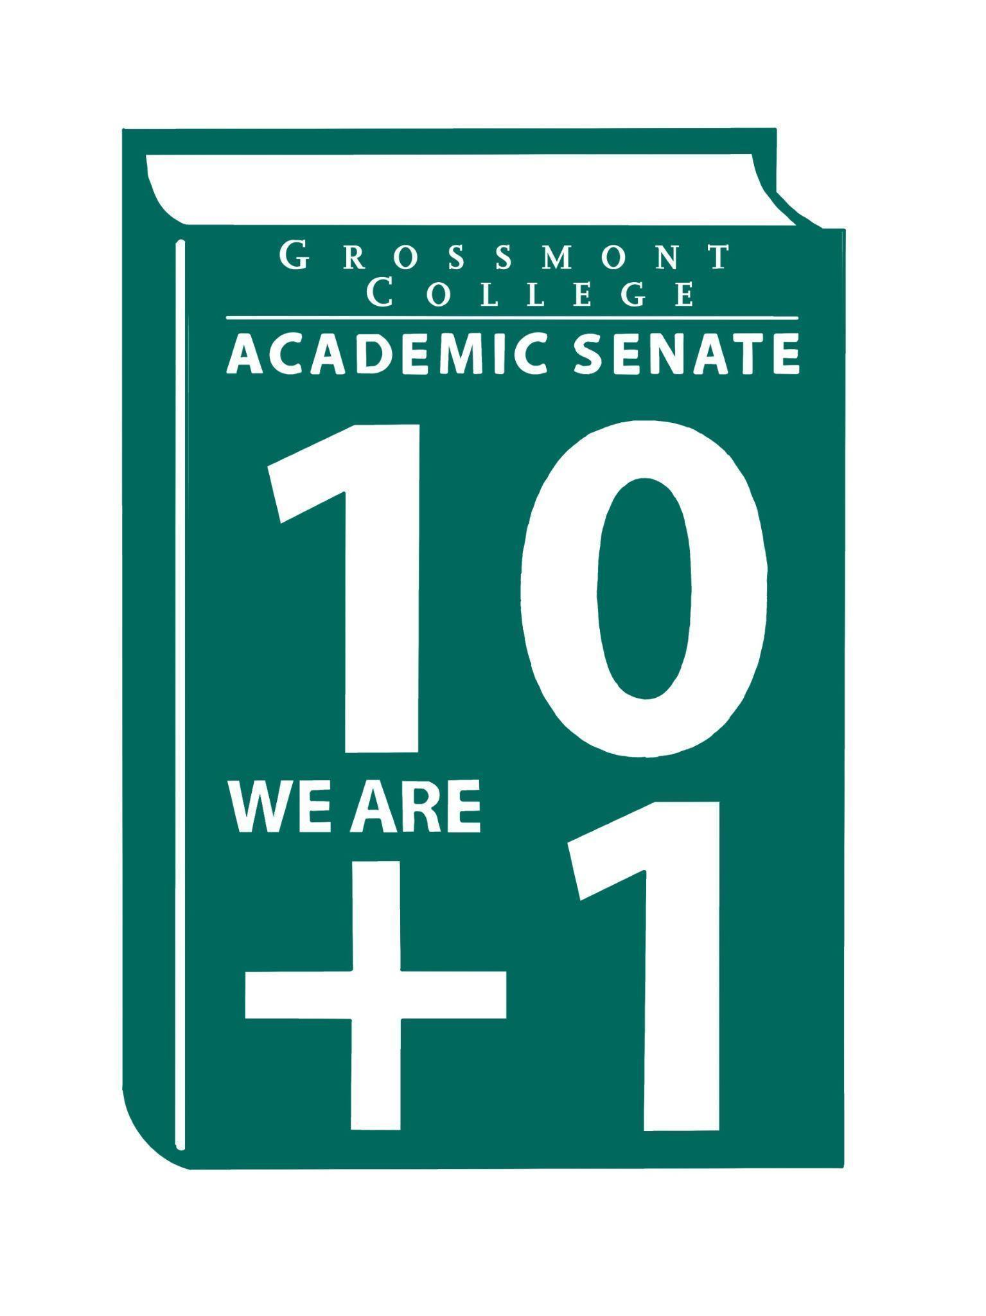

Meeting Minutes of the Academic Senate
Grossmont College
November 3, 2025
11:00 am-12:20 pm
ATTACHMENTS
1 | Call to Order 11:06 am
2 | Public Comment:  C. Flores & R. Handley (Respiratory Therapy)- Asks for support for Bachelor’s in Respiratory Therapy, no public comment form was submitted.  ASGC President- Advocated Academic Senate to work with ASGC for support of AB1705.
3 | Approval of minutes from October 20, 2025.  VOTE: Minutes approved with no objections  Motion: J. Calo/R. Garcia
4 | Approval of Agenda from November 3, 2025.  VOTE: Agenda approved with no objections, move item 8 to follow President's Report.  Motion: J. Calo/Susan  Motion to approve: Malia/J. Waller
5  5.1  5.2  5.3  5.4 | Announcements  Reminder Support-Active Duty/Veterans Day Event (11/10/25)  The Academic Senate will host a Veterans Day support event from 8:00 a.m. to 12:00 p.m. in the Math Building, offering a continental breakfast. Donations are requested.  Child Development Program (Family Night Support)  Hosting an annual Family Night event and seeks monetary support to help fund the occasion.  Basic Needs Resources (Supporting our students)  An email was sent to promote student support and to inform students about the available resources.  Academic Senate Google Site-Active with posted ASCCC Announcements  Located on the AS website under the Resources section; the Google Site will serve as the hub for ASCCC announcements.
6  6.1  6.2  6.3  6.4  6.5 | President’s Report  Human Resources Council Update (AP 2710)  AP 2710 reviewed at the Human Resources Council. Concerns were raised regarding the policy language. Additionally, a comment was made that unless the language comes from CCLC or a similar source, it appears to have been created at the local level and can be modified. There was support for striking a sentence that specifically calls for HR approval prior to securing outside employment.  Draft Academic Calendar 2027-2028  A decision was made at the District level to remove faculty voices. Comments were raised regarding whether grading due dates are reflected in the Academic Calendar; this topic will be added to the list of questions for further review. 2026-2027 Calendar is not on Grossmont Website.  Modification of Faculty Prioritization Committee Proposal (Charge & Composition changes)  A recommendation was made to include one classified representative and to increase faculty representation on the new charge and composition. The proposed draft includes the following information:  Co-chairs: VP of Instruction and Academic Senate President or designee  Committee Membership:  - One faculty member from each of the college’s six instructional divisions as well as the Student Services division (AHN, ALC, CTE/WD, ESBS, MS, LTR, Student Services)  - Note: Prioritization of requests should wait until all division representatives have been appointed by Academic Senate.  - Two instructional deans  - One classified representative  - ASGC president or designee  - Vice-President of Student Services as ex-officio member  - Note: We also discussed needing to follow the term limits provided in the governance handbook. We are bringing this proposal to the Staffing Committee and then the Staffing Committee will determine if they would like to send a recommendation to adopt this model to College Council  .Student arrest on campus (Follow-up requested from College/District)  - Students have expressed very real concerns about the increased risk of being racially profiled after the arrest and the public broad campus email with the student’s physical profile widely circulated.  - Black and African American students specifically have shared fear that they may now be misidentified, stopped, questioned, or surveilled simply for looking similar which compounds historic and ongoing harms tied to criminalization of Black bodies.  - Students are deeply concerned about their personal safety, emotional well-being, and their ability to be on this campus without being perceived as a threat.  - The response, particularly the heavy law enforcement presence the following day, created trauma, not reassurance. Students are asking: Is the campus safe FOR US?  - There is also fear that since the college community has essentially been deputized (through the campus communication) to call 911 if they see someone who resembles the student this places all Black male students in jeopardy.  - Student leaders have been overheard making statements such as “I figure it was one of them.”  - Students inquired as to whether there was a Public Safety Committee that reviews such matters and asks for input to address the matter with cultural humility.  - Students have encouraged each other to make sure that have identification on them at all times in the unfortunate event that are falsely misidentified.  - Faculty and student voices must be centered in determining improved protocols so that campus safety does not become a mechanism of racial harm.  - The institution must affirm clearly that campus safety includes safety from racial targeting, racial surveillance, and racial panic.  Renewing Discretionary Time (RT- delays)  The VPAA is waiting for the application to be reviewed by the District Committee. Updated information is forthcoming.
7  7.1  7.2 | Information Items  Resolution Affirming 10+1 Primacy (1st Read)  AP/BP4021 Program Discontinuance (Please review for recommendations)
8 | Presentations  Facilities Committee Report  R. Gray-  - Kristen Campbell was elected Co-Chair of the Facilities Committee  - 30 FPRs are in for 2025-2026  - Classrooms in Building 51 and 55 are targeted for Fall 2026 use  - FMO staffing remains tight across maintenance, custodial, and grounds  - Basic Needs is planned to move to Building 62  - Event parking requires advance requests
9  9.1  9.2 | Action Items-  Academic Senate One-Year Vision  Faculty Protocol: Responding to Social Media Harassment and Threats
10  10.1  10.2 | Vice-President’s Report/Unfinished Business  Participatory Governance  Senators (Request for updated dept/division reps)
11  11.1  11.2  11.3 | Future Agenda Items  Board of Trustees Follow-up Requests  Evan Wiring & Michael Stewart-CPL  New/Newer Employee Welcome Reception  Robert Henry-History Department (Narrative & Remembrance)
12 | Adjournment:  VOTE: Motion to adjourn: J. VandenEynden/A. Deutsch  Meeting adjourned at 12:21.  Next meeting: November 17, 2025.

SIGN IN
11/3/2025 10:51:17 | Sosha Thomas | Senator | BOT
11/3/2025 10:51:24 | James Holden | Senator | Biology
11/3/2025 10:51:43 | Brian Keliher | Senator | Bus adm
11/3/2025 10:52:29 | Lynn Keane | Senator | BOT
11/3/2025 10:53:56 | Hadeel Yaqoub | Senate Officer (Only SOC) | ESBS
11/3/2025 10:54:14 | Ryan Gray | Senator | Vah
11/3/2025 10:55:01 | Sébastien Cormier | Senator | Physics and Astronomy
11/3/2025 10:55:15 | Randy Abshier | Senator | ESNH
11/3/2025 10:55:31 | Karen Caires | Senator | Exercise Science, Nutrition, and Health
11/3/2025 10:56:00 | Susan Working | Senator | Math
11/3/2025 10:56:59 | Patrice Braswell | Senator | A.R.C.
11/3/2025 10:57:08 | Michele Perchez | Senator | Biology
11/3/2025 10:57:26 | Romeo Madrid Jr. | Guest | Nursing
11/3/2025 10:57:30 | Carey Flores | Senator | Respiratory therapy
11/3/2025 10:57:32 | Felicia Kalker | Senator | Library
11/3/2025 10:57:41 | Amanda Clay | Senator | Orthopedic Tech Program
11/3/2025 10:57:46 | Holly Reed | Senator | OTA
11/3/2025 10:58:02 | Regina Garcia | Senator | Cardiovascular Tech Program
11/3/2025 10:59:56 | Jamie Gould | Senator | ASL
11/3/2025 11:00:36 | Angela Feres | Senator | History
11/3/2025 11:01:18 | June yang | Senate Officer (Only SOC) | Phil and Relg
11/3/2025 11:01:24 | Joel Castellaw | Senator | Communication
11/3/2025 11:01:29 | Diana Vance | Senator | Chemistry and Science
11/3/2025 11:02:21 | Dr. Vanessa Fountain | Guest | ALC
11/3/2025 11:02:29 | Aleksandra | Senator | ESL
11/3/2025 11:02:38 | Brodney Fitzgerald | Senator | Physics and Astronomy
11/3/2025 11:02:41 | Rebecca Handley | Senator | RESP
11/3/2025 11:03:33 | Scott Therkalsen | Senator | Earth sciences
11/3/2025 11:03:34 | Lara Braff | Senator | Anth/Behavioral Sciences
11/3/2025 11:04:07 | Karen Hern | Senator | Business Administration
11/3/2025 11:04:08 | Adam Deutsch | Senate Officer (Only SOC) | English
11/3/2025 11:04:32 | Dylan Wells | Senator | English, adjunct faculty
11/3/2025 11:04:38 | Michael Perez | Senator | EOPS
11/3/2025 11:04:51 | Raymond Funk | Senator | Mathematics
11/3/2025 11:05:17 | Ruth Navarro | Senator | World languages
11/3/2025 11:05:28 | Philip Bell | Senator | CSIS
11/3/2025 11:05:30 | Jeff Waller | Senator | Math
11/3/2025 11:05:40 | Robin Sepulveda | Senator | CDEFS
11/3/2025 11:05:40 | Hau Nguyen | Senator | CSIS
11/3/2025 11:05:45 | Denise Aceves | Senator | Counseling
11/3/2025 11:05:54 | Jennifer Vanden Eynden | Senator | Math
11/3/2025 11:06:13 | Vi Huynh | Guest | ASGC
11/3/2025 11:06:23 | Gina Sorensen | Senator | Dance
11/3/2025 11:06:30 | Alan Traylor | Senate Officer (Only SOC) | English
11/3/2025 11:06:40 | Sarah Moore | Senator | Counseling
11/3/2025 11:06:50 | Patricia Chow | Senator | CTE / Business
11/3/2025 11:06:51 | Natalia Aylett | Senator | English as a Second Language
11/3/2025 11:06:55 | Michelle Crooks | Senator | English
11/3/2025 11:07:24 | Kathleen Banville | Senator | Theatre Arts
11/3/2025 11:07:30 | Malia Molina | Senator | Art History
11/3/2025 11:07:40 | Nancy Saks | Guest | Ahn
11/3/2025 11:07:44 | Martin Larter | Senator | Chemistry
11/3/2025 11:09:16 | Rukiya Akua | Guest | Communication | Not Applicable
11/3/2025 11:09:29 | Jeanette Calo | Senator | Media Communications
11/3/2025 11:13:43 | Diana Ramirez | Senate Officer (Only SOC) | Counseling
11/3/2025 11:16:22 | Gareth Davies-Morris | Senator | VAH
11/3/2025 11:19:35 | Jonathan Martin | Senator | History
11/3/2025 11:31:06 | James foran | Senator | Culinary
11/3/2025 11:35:25 | Gabrielle gosselin | Guest | CalWORKs

