

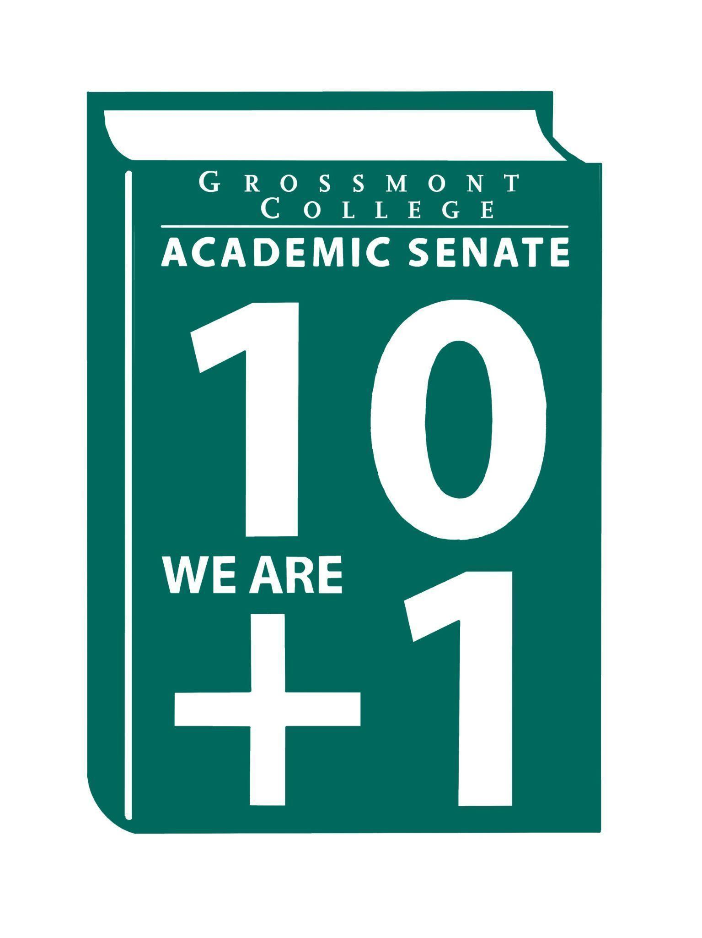

Meeting Minutes of the Academic Senate
Grossmont College
October 20, 2025
11:00 am-12:20 pm
ATTACHMENTS
1 | Call to Order 11:06 am
2 | Public Comment:
3 | Approval of minutes from October 6, 2025.  VOTE: Minutes approved with no objections  Motion: D. Aceves/J. Waller/J. Calo
4 | Approval of Agenda from October 20, 2025.  VOTE: Agenda approved with no objections, amend Q&A between 8.2 and 8.3 for faculty and classified staffing approved positions  Motion: D. Aceves/J. Waller/J. Calo
5  5.1  5.2  5.3  5.4 | Announcements  Support/Active Duty/Veterans Day Event (11/10/25)  Honoring active duty service members for Veterans Day, with the possibility of distributing food the day before.  Area D Resolutions (ASCCC)  Providing updates on resolutions and requesting input on which ones to support  Facilities Equity (Basic Needs Relocating to the Bookstore)  Relocating to improve accessibility for students, with the addition of a washer and dryer.  AFT Know your Contract Mtg (10/16/25)  Facilitated last week; A call-out for volunteers to convene a small task force to create strategies/recommendations to address the contractual 5.3.3.1 language is forthcoming. It is hoped that colleagues from the OTLC team and the evaluation task force will volunteer to provide input and present the recommendations to the Senate before submission to AFT.
6  6.1  6.2  6.3  6.4  6.5 | PRESIDENT’S REPORT- Dr. Sharon Sampson  AP/BP (recommended language that includes “consultation with Academic Senate”) to ensure that the Academic Senate is referenced in the language. D. Aceves recommended drafting a resolution to address the issue formally.  Campus Safety Measures (Exploration of C-CERT Campus Community Emergency Response Teams)  The college president would like to establish a C-CERT on campus to better handle emergencies. She will continue to research options for the best path forward at the college.  Equitable Access to Food (Interim President & VPAS’s Exploration of Fresh Vending by Admin & Contract with local coffee shop owner)  GC is exploring contracting with a local coffee shop from the La Mesa area to reopen the space in the Griffin Center. GC’s leadership is also exploring fresh vending options to be available in multiple locations across the campus.  Swapmeet coming to GC campus (VPAS is negotiating revenue-generating income for facilities with owners of the Santee Swapmeet)  A contract with the Swapmeet owners is pending. This will open the campus to the surrounding community.  EEOAC-New HIRE Training  The Vice Chancellor of Human Resources revamped the training. A copy of the presentation was included in the attachment folder for your perusal. Please provide any feedback on the training so it can be shared at the next EEOAC meeting.
7  7.1  7.2  7.3 | Information Items  Protocol Workplace Violence-(Academic Freedom) (Revisiting)  Feedback has been received from M. Molina & M. Crooks. The next step is to move the draft as an action item. The document will be formally shared with the College Council and DEC if approved.  AP 4105: Distance Education (Please review for recommendations)  In the attachments, please review and provide feedback. Feedback is especially requested from the Curriculum and the OTLC team.
8  8.1  8.2  8.3  8.4 | Presentations  Karolia Macias & Dr. Victoria Rodriguez (Approval for 2025-2028 Student Equity Plan)  Student Equity Plan Draft: The SS&E Committee requests the Senate’s feedback on the plan. A QR code was provided, and a copy of the presentation is attached. Feedback from AS includes clarification on how the data are disaggregated, specifically regarding the Middle Eastern population, which is identified as white in the data. The deadline to submit feedback is October 31, 2025.  Tate Hurvitz-Student Printing Options Taskforce Update  Due to widespread dissatisfaction with the current WEPA printing service, a districtwide task force—comprising faculty, classified professionals, and administrators with direct experience—was formed last year to explore alternatives. The group has reviewed proposals from various vendors and would like to share the process and options considered briefly. While this may not be a 10+1 matter, we aim to keep the Academic Senate informed and welcome feedback.  June Yang-Team Teaching  Held a discussion and surveyed team teaching, covering its various models and benefits. The survey is also being used to gather feedback.  Faculty Representatives Reports- Senate & Participatory Governance Committees
9  9.1  9.2  9.3 | Action Items  Academic Senate Norms  Motion: J. Calo/M. Molina  Motion Passed  Academic Senate One-Year Vision  Motion: J. Waller/J. Yang  J. Waller shares feedback regarding 10+1  Motion to table the One-Year Vision to the next meeting:  Motion: J. Waller/M. Molina  MOU-National University  Amended language for the voting form. D. Aceves and S. Moore presented a written statement.  Motion: J. Waller  Motion Failed
10  10.1  10.2 | Vice-President’s Report/Unfinished Business  Participatory Governance (open active recruitments)  Senators (Updating dept/division reps)
11  11.1  11.2  11.3 | Future Agenda Items  Board of Trustees Follow-up Requests  Invitation to the College Interim President  New/Newer Employee Welcome Reception
12 | Adjournment:  VOTE: Motion to adjourn: D. Aceves/R. Garcia  Meeting adjourned at 12:19.  Next meeting: November 3, 2025.

SIGN IN

10/20/2025 10:51:32 | Karen Hern | Senator | Business Administration
10/20/2025 10:53:59 | Dylan Wells | Senator | English - adjunct faculty
10/20/2025 10:54:43 | Adam Deutsch | Senate Officer (Only SOC) | ESBS
10/20/2025 10:55:18 | Susan Working | Senator | Math
10/20/2025 10:55:55 | James Holden | Senator | BIO
10/20/2025 10:57:59 | June Yang | Senate Officer (Only SOC) | Phil and Relg
10/20/2025 10:58:33 | Patrice Braswell | Senator | A.R.C.
10/20/2025 10:58:43 | Randy Abshier | Senator | ESNH
10/20/2025 10:59:39 | Lynn Keane | Senator | BOT
10/20/2025 10:59:46 | Kathleen Banville | Senator | Theatre Arts
10/20/2025 11:00:21 | Angela Feres | Senator | History ESBS
10/20/2025 11:01:06 | Sosha Thomas | Senator | BOT
10/20/2025 11:01:21 | Regina Garcia | Senate Officer (Only SOC) | Cardiovascular Technology
10/20/2025 11:01:24 | Hadeel Yaqoub | Senate Officer (Only SOC) | ESBS
10/20/2025 11:02:18 | Patricia Chow | Senator | CTE/ Business
10/20/2025 11:02:30 | Amanda Clay | Senator | Orthopedic Tech Program
10/20/2025 11:02:58 | Gina Sorensen | Senator | Dance
10/20/2025 11:03:02 | Jamie Gould | Senator | ASL
10/20/2025 11:03:11 | Natalie Ray | Senator | Counseling
10/20/2025 11:03:20 | Lara Braff | Senator | ANTH/behavioral sciences
10/20/2025 11:03:31 | Wendy Cruzado | Proxy for Senator | Counseling | Sarah Moore
10/20/2025 11:03:33 | Diana Vance | Senator | Chemistry and Science
10/20/2025 11:03:38 | Jeff Waller | Senator | Mathematics
10/20/2025 11:03:39 | Michael Perez | Senator | EOPS
10/20/2025 11:03:43 | Hau Nguyen | Senator | CSIS
10/20/2025 11:03:44 | Julie Schanze | Guest | Mental Health
10/20/2025 11:04:31 | Ryan Gray | Senator | Vah
10/20/2025 11:05:41 | Felicia Kalker | Senator | Library
10/20/2025 11:05:57 | Denise Aceves | Senator | Counseling
10/20/2025 11:06:04 | Raymond Funk | Senator | Mathematics
10/20/2025 11:06:19 | Robin Sepulveda | Senator | CDEFS
10/20/2025 11:06:28 | Malia Molina | Senator | Art History
10/20/2025 11:06:41 | Victoria Curran | Senator | Communication
10/20/2025 11:07:09 | Judd Curran | Senator | Earth Sciences
10/20/2025 11:08:59 | Eva nicasio | Senator | Mmib
10/20/2025 11:09:34 | Jennifer Vanden Eynden | Senator | Mathematics
10/20/2025 11:09:39 | Natalia Aylett | Senator | English as a Second Language
10/20/2025 11:10:53 | Martin Larter | Senator | Chemistry
10/20/2025 11:11:00 | Jeanette Calo | Senator | Media Communications
10/20/2025 11:11:11 | Elisabeth Burke | Senator | Philosophy and Religious Studies
10/20/2025 11:11:25 | Ruth Navarro | Senator | wld
10/20/2025 11:22:50 | Jonathan Martin | Senator | History
10/20/2025 11:37:14 | Joel Castellaw | Senator | Communication
10/20/2025 11:49:37 | Philip Bell | Senator | CSIS
10/20/2025 12:16:14 | Carey Flores | Senator | Respiratory therapy
10/20/2025 12:16:22 | Rebecca Handley | Senator | RESP

Academic Senate Norms Voting:

10/20/2025 11:53:25 | Felicia Kalker | Aye
10/20/2025 11:53:25 | Susan Working | Aye
10/20/2025 11:53:26 | Jenny Vanden Eynden | Aye
10/20/2025 11:53:33 | Amanda Clay | Aye
10/20/2025 11:53:36 | Jamie Gould | Aye
10/20/2025 11:53:36 | Dee Aceves | Aye
10/20/2025 11:53:36 | Regina Garcia | Aye
10/20/2025 11:53:38 | Ryan Gray | Aye
10/20/2025 11:53:39 | Jeff Waller | Aye
10/20/2025 11:53:40 | Rebecca Handley | Aye
10/20/2025 11:53:40 | Victoria Curran | Aye
10/20/2025 11:53:41 | Elisabeth Burke | Aye
10/20/2025 11:53:41 | Jeanette Calo | Aye
10/20/2025 11:53:43 | Aye | Aye
10/20/2025 11:53:45 | Judd Curran | Aye
10/20/2025 11:53:46 | Lara Braff | Aye
10/20/2025 11:53:49 | Dylan Wells | ABSTAIN
10/20/2025 11:53:49 | Carey Flores | Aye
10/20/2025 11:53:49 | Eva nicasio | Aye
10/20/2025 11:53:50 | Adam Deutsch | Aye
10/20/2025 11:53:50 | Natalie Ray | Aye
10/20/2025 11:53:51 | Angela Feres | Aye
10/20/2025 11:53:53 | Randy Abshier | Aye
10/20/2025 11:53:53 | Karen Hern | Aye
10/20/2025 11:53:53 | Lynn Keane | Aye
10/20/2025 11:53:54 | Joel Castellaw | Aye
10/20/2025 11:53:55 | Raymond Funk | Aye
10/20/2025 11:53:57 | Ruth navarro | Aye
10/20/2025 11:53:58 | Julie | Aye
10/20/2025 11:53:58 | Wendy Cruzado - proxy for Sarah Moore | Aye
10/20/2025 11:53:58 | Gina Sorensen | Aye
10/20/2025 11:54:00 | Diana | Aye
10/20/2025 11:54:01 | James Holden | Aye
10/20/2025 11:54:02 | Patrice Braswell | Aye
10/20/2025 11:54:03 | Patricia Chow | Aye
10/20/2025 11:54:04 | Robin Sepulveda | Aye
10/20/2025 11:54:04 | Natalia Aylett | Aye
10/20/2025 11:54:17 | Hadeel Yaqoub | Aye
10/20/2025 11:54:24 | Jonathan Martin | Aye
10/20/2025 11:54:26 | Martin Larter | Aye
10/20/2025 11:54:28 | Sosha Thomas | Aye

MOU-National University Voting:

10/20/2025 12:16:51 | Adam Deutsch | NO
10/20/2025 12:16:52 | Denise Aceves | NO
10/20/2025 12:16:54 | Susan Working | NO
10/20/2025 12:16:58 | Carey Flores | NO
10/20/2025 12:16:58 | Malia Molina | NO
10/20/2025 12:16:58 | Jonathan Martin | NO
10/20/2025 12:16:59 | Felicia Kalker | NO
10/20/2025 12:16:59 | Angela Feres | NO
10/20/2025 12:17:00 | Gina Sorensen | NO
10/20/2025 12:17:00 | Karen Hern | NO
10/20/2025 12:17:02 | Lara Braff | NO
10/20/2025 12:17:03 | Jennifer Vanden Eynden | NO
10/20/2025 12:17:03 | Regina Garcia | NO
10/20/2025 12:17:04 | Natalia Aylett | NO
10/20/2025 12:17:04 | Dylan Wells | NO
10/20/2025 12:17:05 | Jeanette Calo | NO
10/20/2025 12:17:05 | Julie Schanze | NO
10/20/2025 12:17:05 | Ryan G | NO
10/20/2025 12:17:07 | Jeff Waller | NO
10/20/2025 12:17:09 | James Holden | NO
10/20/2025 12:17:10 | Jamie Gould | NO
10/20/2025 12:17:12 | June Yang | NO
10/20/2025 12:17:13 | Kathleen Banville | NO
10/20/2025 12:17:14 | Natalie Ray | ABSTAIN
10/20/2025 12:17:15 | Hadeel Yaqoub | Aye
10/20/2025 12:17:16 | Amanda Clay | NO
10/20/2025 12:17:16 | Lynn Keane | NO
10/20/2025 12:17:16 | Wendy Cruzado - proxy for Sarah Moore | NO
10/20/2025 12:17:17 | Elisabeth Burke | NO
10/20/2025 12:17:17 | Raymond Funk | NO
10/20/2025 12:17:17 | Rebecca Handley | NO
10/20/2025 12:17:18 | Patricia Chow | Aye
10/20/2025 12:17:19 | Eva Nicasio | NO
10/20/2025 12:17:25 | Ruth navarro | NO
10/20/2025 12:17:26 | Robin Sepulveda | NO
10/20/2025 12:17:32 | Diana | NO
10/20/2025 12:17:38 | Michael Perez | Aye
10/20/2025 12:17:40 | Patrice Braswell | NO
10/20/2025 12:17:53 | Philip Bell | ABSTAIN
10/20/2025 12:18:11 | Hau Nguyen | NO

