

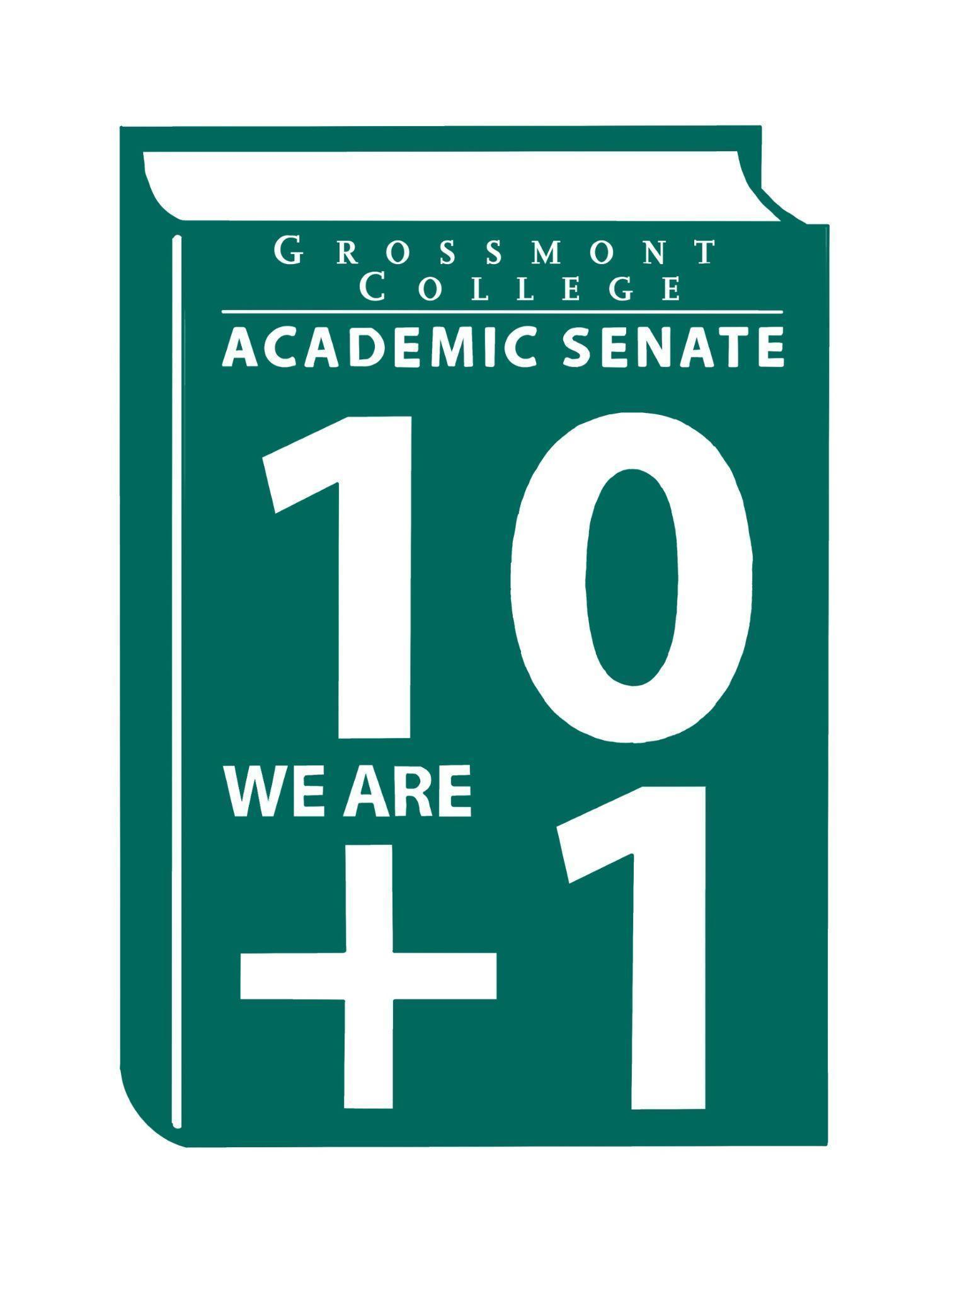

Meeting Minutes of the Academic Senate
Grossmont College
October 6, 2025
11:00 am-12:20 pm
ATTACHMENTS
1 | Call to Order 11:11 am
2 | Public Comment:  Victor T. -Judges and Moderators needed for Dec 6th Ethics Bowl, debate competition based on philosophy.
3 | Approval of minutes from September 29, 2025.  VOTE: Minutes approved with no objections  Motion: J. Calo/J. Waller
4 | Approval of Agenda from October 6, 2025.  VOTE: Agenda approved with no objections, amend Q&A between 8.2 and 8.3 for faculty and classified staffing approved positions  Motion: J. Calo/J. Waller
5  5.1  5.2  5.3  5.4 | Announcements  Faculty and Staff Prioritization Approved Positions  Classified positions, 18 with personnel. 5 faculty positions funded.  Questions asked regarding reasoning behind hiring decisions. Comments made that technically only three positions were funded. Biology was a tenure track position and CVT’s hiring process is underway.  Academic Freedom Webinar (ASCCC)  Brought to attention based on the previous cyber-attack on the faculty.  Volunteers for the Online Evaluation Taskforce from the following groups:  - Tenure review  - AFT  - Senate  Volunteers for Sabbatical Taskforce  One more volunteer needed.
6  6.1  6.2  6.3  6.4 | PRESIDENT’S REPORT- Dr. Sharon Sampson  AUP-submitted  The AUP for AS was completed by the 10/1/25 deadline. Input will be requested in the completion of future iterations of the AUP.  Cuyamaca’s Feedback on MOU w/ National University  Permission has been granted for Grossmont to share Cuyamaca’s questions regarding the MOU. The document was uploaded in the attachment folder.  Draft Timeline for New and Renewal Discretionary (Academic Affairs)  There is a new reassigned time and timeline draft proposal from the interim VPAA. Recommendations/modifications are welcomed.  Off-Campus Travel Form (Review of changes)  Please refer to the attachments. As of July, the process has changed: group travel submissions are no longer accepted—each individual must now submit their own request.
7  7.1  7.2 | Information Items  Protocol Workplace Violence-(Academic Freedom) (Revisiting)  The document is accessible in the attachment folder, recommendations/input are welcomed. The modifications will be synthesized with a clean copy will be uploaded. The deadline for comments is Thursday 10/16/25, before the next Senate meeting.  BP 5040: Student Records, Directory Information, and Privacy  BP 5500: Standard of Student Conduct  Board policy being presented to the Senate for review. The request is for the Senate to use the green color font when making recommendations. CCLC language noted in red cannot be changed.
8  8.1  8.2  8.3  8.4 | Presentations  Joyce Fries & Kelly Menck-Program Review Update  The Academic Program Review update included evaluations of the Arts, Dance, and Media Communications Division. Commendations highlighted progress on Student Learning Outcomes (SLOs). The most common recommendations from the committee were shared, along with updates on current improvement efforts. Access. The documents are available on the website.  June Yang-Team Teaching  Postponed  Karolia Macias & Dr. Victoria Rodriguez (2025-2028 Student Equity Plan Draft)  Student Equity Plan draft shared which included a review of progress, timeline, and framework. Some highlights include: an executive summary, data review, and top 3 strategies for successful enrollment.  Faculty Representatives Reports-Participatory Governance Committees
9  9.1  9.2  9.3 | Action Items-Postponed due to limited time  Academic Senate Norms  Academic Senate One-Year Vision  MOU-National University
10  10.1  10.2 | Vice-President’s Report/Unfinished Business  Participatory Governance  Senators (Request for updated dept/division reps)
11  11.1  11.2 | Future Agenda Items  Resolutions-ASCCC  Karolia Macias & Dr. Victoria Rodriguex (2025-2028 Student Equity Plan Approval)
12 | Adjournment:  VOTE: Motion to adjourn: J. VandenEynden/L. Braff  Meeting adjourned at 12:23.  Next meeting: October 20, 2025.

SIGN IN

10/6/2025 11:06:51 |  | Senator | Malia Molina
10/6/2025 11:07:26 | Holly Reed | Senator | OTA
10/6/2025 11:07:28 | Kathleen Banville | Senator | Theatre Arts
10/6/2025 11:07:32 | Victor Abundez-Guerra | Guest | Philosophy
10/6/2025 11:07:34 | Angela Feres | Senator | Hist ESBS
10/6/2025 11:07:36 | Michelle crooks | Senator | English
10/6/2025 11:07:36 | Jeanette Calo | Senator | MCOM
10/6/2025 11:07:36 | Barbara Gallego | Guest | ESS
10/6/2025 11:07:36 | Martin Larter | Senator | Chemistry
10/6/2025 11:07:38 | Jennifer Vanden Eynden | Senator | Math
10/6/2025 11:07:43 | Robin Sepulveda | Senator | CDEFS
10/6/2025 11:07:44 | Lynn Keane | Guest | BOT
10/6/2025 11:07:44 | Natalie Ray | Senator | Counseling
10/6/2025 11:07:45 | Ryan Gray | Senator | Vah
10/6/2025 11:07:48 | Adam Deutsch | Senate Officer (Only SOC) | ESBC
10/6/2025 11:07:48 | Joyce Fries | Guest | Occupational therapy assistant
10/6/2025 11:07:51 | Joel Castellaw | Senator | Communication
10/6/2025 11:07:53 | Brodney Fitzgerald | Senator | Physics and Astronomy
10/6/2025 11:08:02 | Brian Keliher | Senator | Bus adm
10/6/2025 11:08:02 | Wendy Cruzado | Proxy for Senator | Counseling | Sarah Moore
10/6/2025 11:08:02 | Nancy Saks | Guest | Nancy SaKs AHN
10/6/2025 11:08:07 | Ruth navarro | Senator | World languages
10/6/2025 11:08:12 | Regina Garcia | Senate Officer (Only SOC) | Cardiovascular Technology
10/6/2025 11:08:13 | Jeff Waller | Senator | Mathematics
10/6/2025 11:08:13 | Natalia Aylett | Senator | ESL
10/6/2025 11:08:15 | Randy Abshier | Senator | ESNH
10/6/2025 11:08:18 | Diana Vance | Senator | Chemistry and Science
10/6/2025 11:08:21 | Patricia chow | Senator | CTE / business
10/6/2025 11:08:25 | Jonathan Martin | Senator | History Department
10/6/2025 11:08:34 | Elisabeth Burke | Senator | Philosophy and Religious Studies
10/6/2025 11:08:35 | Gina Sorensen | Guest | Dance
10/6/2025 11:08:35 | Courtney Willlis | Guest | Student Services
10/6/2025 11:08:35 | Raymond Funk | Senator | Mathematics
10/6/2025 11:08:42 | Michele Perchez | Senator | Biology
10/6/2025 11:08:42 | Hau Nguyen | Senator | CSIS
10/6/2025 11:08:44 | Felicia Kalker | Senator | Library
10/6/2025 11:08:53 | Shawn Hicks | Guest | Math and Sciences Division Dean
10/6/2025 11:09:11 | Lara Braff | Senator | Behavioral Sciences/ANTH
10/6/2025 11:09:15 | Michael Perez | Senator | EOPS/CARE
10/6/2025 11:09:36 | Ricardo crespo | Senator | Political economy
10/6/2025 11:09:40 | Victoria Rodriguez | Guest | SS&E
10/6/2025 11:09:44 | Diana Ramirez | Senate Officer (Only SOC) | Counseling
10/6/2025 11:09:51 | Karen Cairrs | Senator | ESNH
10/6/2025 11:10:32 | Judd Curran | Senator | Earth Sciences
10/6/2025 11:10:41 | Tate Hurvitz | Guest | CPIE
10/6/2025 11:10:43 | Dr. Vanessa Fountain | Guest | ALC
10/6/2025 11:10:48 | Kelly Menck | Senator | Aoj
10/6/2025 11:12:24 | Gareth Davies/Morris | Senator | Visual Arts & Humanities
10/6/2025 11:13:40 | Sosha Thomas | Senate Officer (Only SOC) | Bot
10/6/2025 11:26:57 | Philip Bell | Senate Officer (Only SOC) | CSIS
10/6/2025 11:27:07 | Philip Bell | Senator | CSIS

