
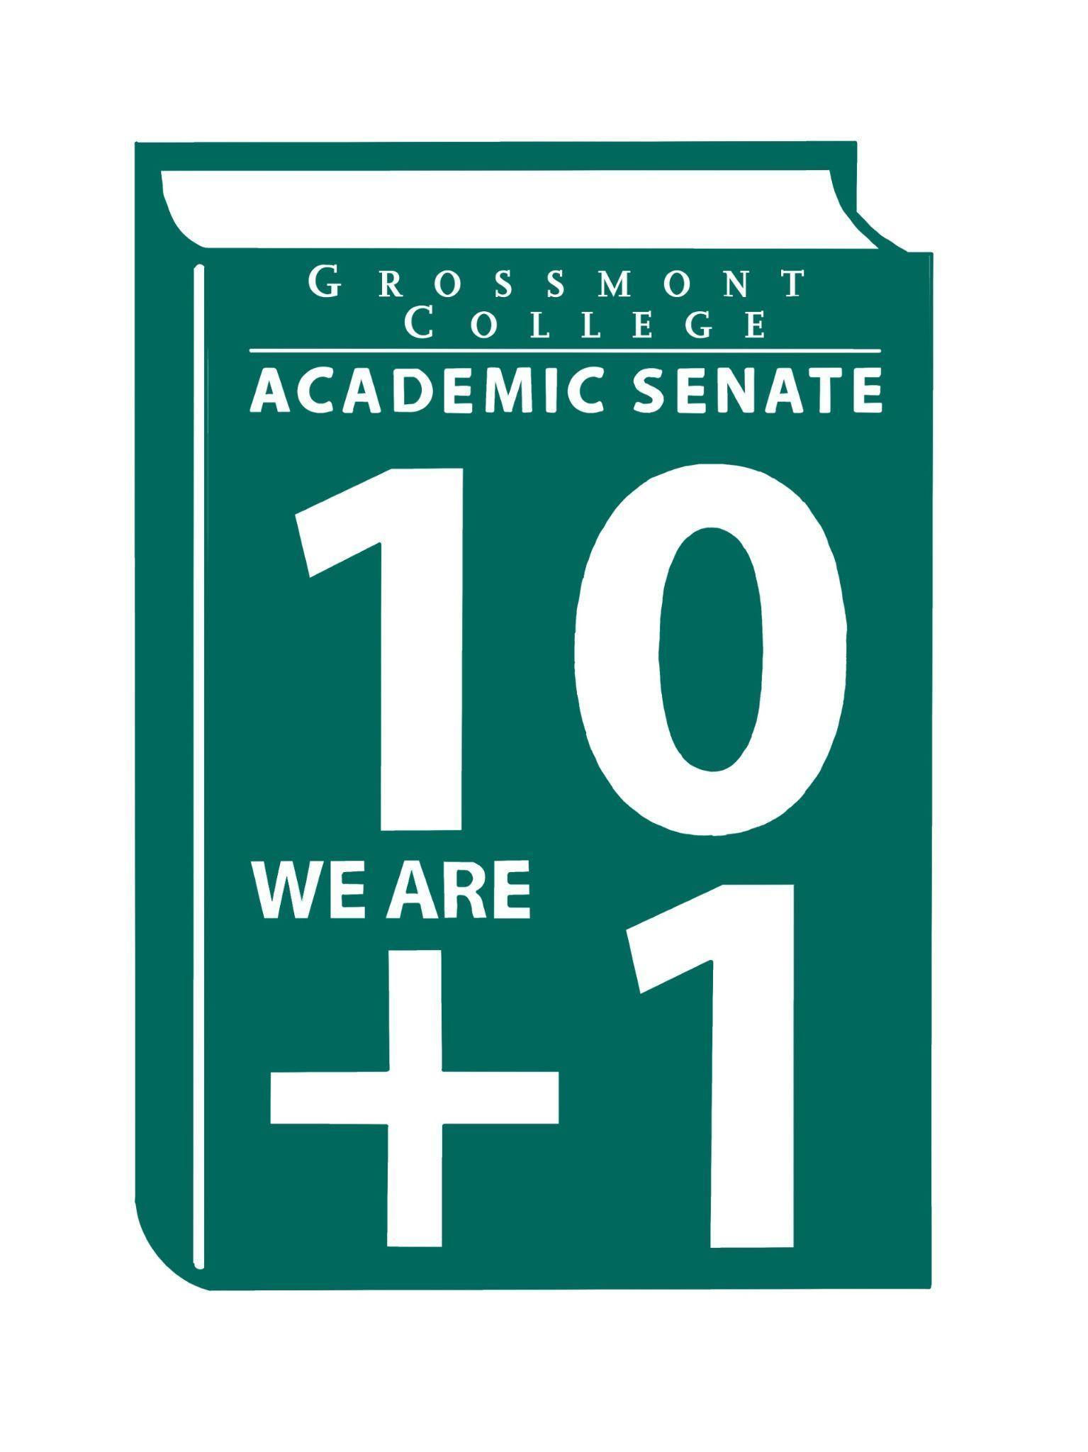

Meeting Minutes of the Academic Senate
Grossmont College
September 29, 2025
11:00 am-12:20 pm
ATTACHMENTS
1 | Call to Order 11:11 am
2 | Public Comment:  Natalie R. -Shared the students’ registration timeline for Spring semester courses
3 | Approval of minutes from September 15, 2025.  VOTE: Minutes approved with no objections  Motion: J. Waller/J. Calo
4 | Approval of Agenda from September 15, 2025.  VOTE: Agenda approved with no objections, slight change to move up MOU presentation
5  5.1  5.2  5.3  5.4 | Announcements  Sabbatical Leave Taskforce Volunteers  A formal call is being made for 2–3 volunteers to join the Sabbatical Leave Taskforce.  Launch of Google Site for external announcements & resources  The Google site will be published and linked to the Academic Senate website, featuring ASCCC announcements and professional development opportunities.  Chancellor’s Forum (9/29/25-Griffin Gate)  Chancellor’s Forum will take place at 1:30 PM on Monday, September 29, 2025, at Griffin Gate.  Common Course Numbering (CCN) PHase III post-convening surveys (closes 9/29/25)  Phase III survey closes 9/29/25, your feedback is important.
6  6.1  6.2  6.3  6.4  6.5 | PRESIDENT’S REPORT- Dr. Sharon Sampson  Mtg with President & Interim VP  The goal of the meeting was to engage in a conversation with administrators to support students concerning the 10+1 areas.  Invite to Counseling Chairs/Coordinators to attend SOC mtg.  Counselors are invited to the Senate meeting on Friday, following a counselor’s recommendation, as their voices are vital in this space.  Follow-up with District IT on Concerns Regarding Geographical Restrictions on Canvas Access  Our colleague raised concerns that students traveling internationally are unable to access Canvas or course materials. We will discuss these challenges with the college president to find solutions for the students affected.  AS President Board Report-Featuring World Languages & Culinary Arts  The World Languages department will facilitate a discussion on collaboration with RSI and high school language education.  AI District Taskforce  A callout for the taskforce was sent, a list of interested faculty was compiled, and they have been contacted.
7  7.1  7.2  7.3  7.4 | Information Items  Faculty Protocol-Workplace Violence  In attachments is a document regarding protocol responding to social media harassment and threats targeting faculty. Requests were made for feedback. A discussion was held on phrasing that respects free speech. Comment made by Jeanette Calo on concerns regarding policy for one faculty member. Comment was also made regarding student discipline when dealing with destructive behavior. Red text is for AFT only.  EEO Resolution-Upcoming Area D Mtg  Resolution based on the Human Resources Council with the EEO plan. Asked faculty to please review.  Workplace Violence Resolution-Upcoming Area D Mtg  Please refer to Workplace Violence Resolution for review.  Please provide feedback on the following items currently being reviewed by the Human Resources Council (HRC)  - Recruitment Timeline  - BP 2510-Participatory Governance  - AP 2510-Participatory Governance  - DEIAA Language for Job Descriptions
8  8.1  8.2  8.3 | Presentations  Assoc Vice-Chancello-B. Gallegos  - Name Change  Students can now declare a preferred name different from their legal name through Self Service. Will be available soon with student ID cards. There are some areas, however, where the legal name will be continued to be used.  - MOU-National University  MOU executive summary was shared. Explained an increase of scholarships for Grossmont students. Also, stated discounts regarding different education levels. Gallegos mentioned that this is a good option for students who are unable to transfer to local universities.  - East County Alliance Focus Plan  Work to operationalize Vision 2030 by aligning its goals with the Alliance’s initiatives. State benchmarks were highlighted under each goal, and key performance indicators were identified.  Joyce Fries & Kelly Menck-Program Review Update  Postponed  OTLC Committee-Clarifications re: the faculty contract  The Online Teaching & Learning Committee discussed a section of the faculty contract, section 5.3.3.1. Discussed guidelines for including student evaluations in Canvas.
9  9.1  9.2  9.3 | Action Items  Academic Senate Norms  Academic Senate One-Year Vision  MOU-National University
10  10.1  10.2 | Vice-President’s Report/Unfinished Business  Participatory Governance (Vacancies)  Save-the-date 10/3/25 (Postponement)
11  11.1  11.2  11.3 | Future Agenda Items  Reports by Faculty Representatives on Participatory & Senate Committees  Presentations by Dr. Victoria Rodriguez-Seeking approval for our 25-28 Student Equity Plan  Team Teaching for Student Success by Dr. June Yang
12 | Adjournment:  VOTE: Motion to adjourn: H. Reed/J. Yang  Meeting adjourned at 12:24.  Next meeting: October 6, 2025.

SIGN IN
9/29/2025 10:44:49 | Nancy Saks | Guest | AHN
9/29/2025 10:52:07 | Randy Abshier | Senator | ESNH
9/29/2025 10:53:53 | Michele Perchez | Senator | Biology
9/29/2025 10:56:48 | Patrice Braswell | Senator | ARC
9/29/2025 10:56:48 | Corey Manchester | Senator | Math
9/29/2025 10:57:08 | Brian keliher | Senator | Bus adm
9/29/2025 10:57:19 | Holly Reed | Senator | OTA
9/29/2025 10:57:24 | Amanda Clay | Senator | Orthopedic Tech Program
9/29/2025 10:57:57 | Victor Abundez-Guerra | Guest | Philosophy
9/29/2025 10:57:58 | Jennifer Vanden Eynden | Senator | Mathematics
9/29/2025 10:58:02 | Susan Working | Senator | Math
9/29/2025 10:58:56 | Karen Hern | Proxy for Senator | Business Administration | Patricia Chow
9/29/2025 10:59:01 | Regina Garcia | Senate Officer (Only SOC) | Cardiovascular Technology
9/29/2025 10:59:25 | Sosha Thomas | Senator | BOT
9/29/2025 11:00:02 | Lynn Keane | Guest | BOT
9/29/2025 11:00:13 | Hadeel Yaqoub | Senate Officer (Only SOC) | ESBS
9/29/2025 11:00:46 | Katie Banville | Senator | Theatre Arts
9/29/2025 11:01:09 | Gina Sorensen | Guest | Dance
9/29/2025 11:01:47 | Adam Deutsch | Senate Officer (Only SOC) | Esbs
9/29/2025 11:01:53 | Jamie Gould | Senator | ASL
9/29/2025 11:02:06 | Natalie Ray | Senator | Counseling
9/29/2025 11:02:39 | Angela Feres | Senator | History ESBS
9/29/2025 11:02:58 | Romeo Madrid | Guest | Nursing
9/29/2025 11:03:03 | Martin Larter | Senator | Chemistry
9/29/2025 11:03:09 | James Holden | Senator | Biology
9/29/2025 11:03:43 | Jeff Waller | Senator | Mathematics
9/29/2025 11:05:30 | Hau Nguyen | Senator | CSIS
9/29/2025 11:05:33 | Jeanette Calo | Senator | MCOM
9/29/2025 11:06:22 | Natalia Aylett | Senator | English as a second language
9/29/2025 11:06:46 | Lara Braff | Senator | Behavioral Sciences/ANTH
9/29/2025 11:06:53 | Dr. Vanessa Fountain | Guest | ALC
9/29/2025 11:07:06 | Scott therkalsen | Senator | Earth science
9/29/2025 11:07:52 | Shawn Hicks | Guest | Math and Sciences Division Dean
9/29/2025 11:08:38 | Ruth Navarro | Senator | World Languages
9/29/2025 11:08:59 | Judd Curran | Senator | Earth Sciences
9/29/2025 11:09:05 | Malia Molina | Senator | Art History/VAH/ALC
9/29/2025 11:09:08 | Victoria Curran | Senator | Communication
9/29/2025 11:09:13 | Barbara Gallego | Guest | DISTRICT ESS
9/29/2025 11:09:47 | Diana Ramirez | Senate Officer (Only SOC) | First Year Services
9/29/2025 11:10:12 | Elisabeth Burke | Senator | Philosophy and Religious Studies
9/29/2025 11:10:16 | Khalid Alkhurie | Senator | ALC
9/29/2025 11:10:20 | June Yanh | Senate Officer (Only SOC) | Phil and Relg
9/29/2025 11:10:27 | Rebecca Handley | Senator | RESP
9/29/2025 11:10:32 | Felicia Kalker | Senator | Library
9/29/2025 11:10:56 | Robin Sepulveda | Senator | CDEFS
9/29/2025 11:16:01 | Karen Caires | Senator | ESNH
9/29/2025 11:16:28 | Raymond Funk | Senator | Mathematics
9/29/2025 11:20:54 | Melonie Grinnell | Guest | Music
9/29/2025 11:22:52 | Joyce Fries | Guest | Occupational therapy assistant
9/29/2025 11:23:12 | Diana Vance | Senator | Chemistry and Science
9/29/2025 11:27:45 | Brodney Fitzgerald | Senator | Physics and Astronomy
9/29/2025 11:28:18 | Gareth Davies-Morris | Senator | Visual Arts and Humanities

