
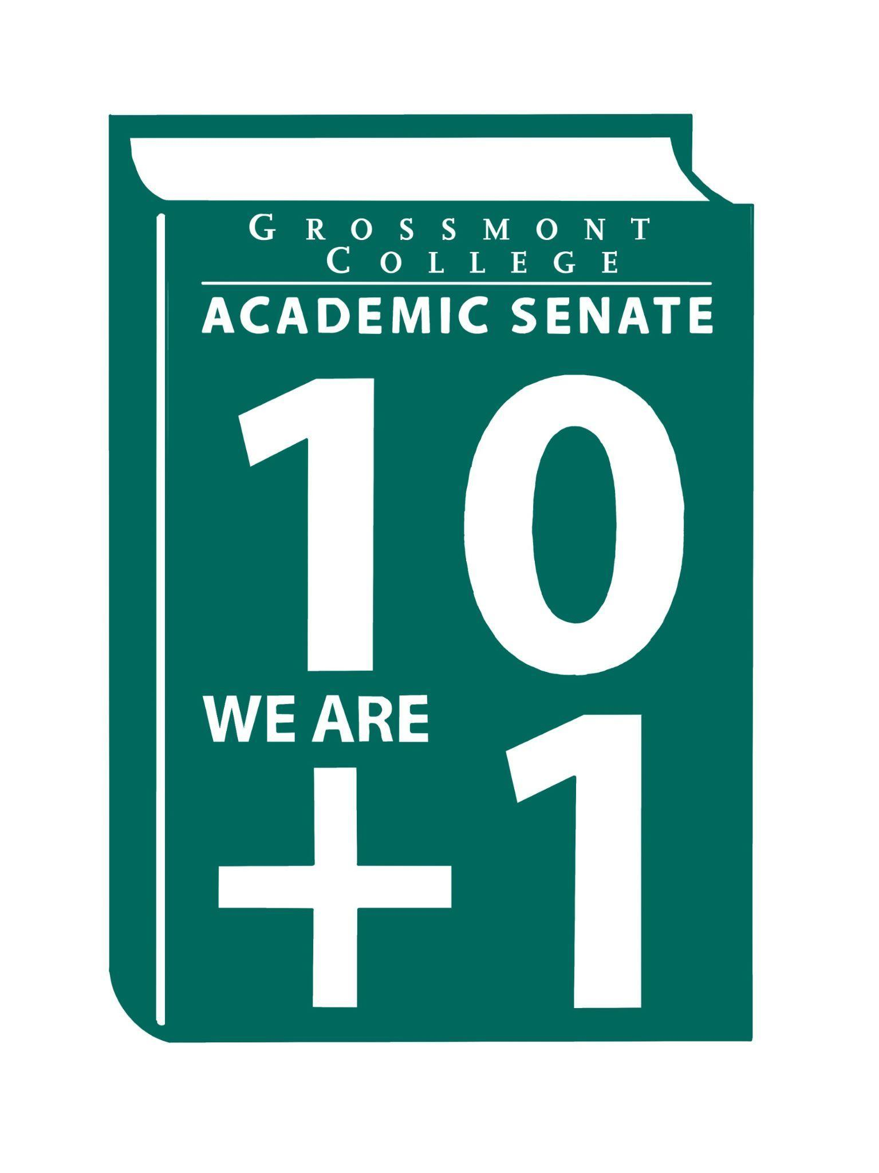

Meeting Minutes of the Academic Senate
Grossmont College
September 15, 2025
11:00 am-12:20 pm
ATTACHMENTS
1 | Call to Order 11:06 am
2 | Public Comment:  Adam D. - advocated for Microsoft licenses for part-time faculty.  Diana R. - Latine Heritage Month- flyer with the events was shared!  Alan T. - Sept 9th, X account targeted faculty at Grossmont College. Encouraged faculty to seek resources if safety is compromised.  Philip B. - The district’s policy restricting email and Canvas access from outside the U.S. causes many issues. Urged IT to work with faculty to develop a more responsive and equitable solution.
3 | Approval of minutes from August 18, 2025.  VOTE: Minutes approved with no objections  Motion: J. Waller/S. Working
4 | Approval of Agenda from September 15, 2025.  VOTE: Agenda approved with no objections
5 | Announcements  A. Fall 2025 Sabbatical Leave Workshops- workshops are mandatory for sabbatical application. The last two workshops will be facilitated on Thursday, September 18th, and Friday, September 19th.  B. Save the Date (Friday 10/3/25)- Senate Retreat Part II  C. Recruitment event 9/26/25 at San Diego State University. HR welcomes faculty interested in attending. This is a great way to recruit colleagues for open positions.  C. ASCCC Fall Plenary- ASCCC will be in La Jolla, November 6–8, 2025. There will be resources to support anyone who would like to attend, and we strongly encourage faculty attendance.  D. Board Meeting Report/Trustee Vacancy- Advocacy to attend Board Meeting to get to know the Board members. Interviews have started for the trustee vacancy. Described the qualities needed for this position.
6  6.1  6.2  6.3 | PRESIDENT’S REPORT- Dr. Sharon Sampson  Guest Parking  - Standard for guest parking includes form and payment  - A discussion was held on the rationale behind these requirements  Key Priorities:  - Participatory Governance  - Thanked those who completed the form for PG Committee volunteers  - District Participatory Governance  - Callout for District Participatory Governance  Meetings  - President-Dr. Pam Luster  - Interim VPAA-Dr. Joan Ahrens  - VPAS-Meya Alamor  - ADSOC  Feel free to email constituents with any questions.
7 | Information Items  - Memorandum of Understanding (MOU) with GCCCD & National University (feedback)  - The district signed the document without faculty voices  - Being brought to the Senate for input  - Referred to a similar MOU from 2018  - GCCCD East County Education Alliance Strategic Plan (feedback)  - document drafted to solidify the relationship with East County education  - Nine key actions to address barriers to economic mobility for students  - Human Resources Council-(requesting feedback on the following):  - Faculty Recruitment Timeline  - Title 5 DEIAA Suggested Language (Job Descriptions)  - AP 2710 Conflict of Interest: attendees expressed confusion about the extent, process, and decision-making for this proposed policy, and have questions.  - AP 2510 Participatory Governance  - BP 2510 Participatory Governance  Presentations  - Denise Schulmeyer/Karen Hern/Karo Macias/Tate Hurvitz-SLO/SSO mapping to PSLOs/ISLOs  - Nearly completed draft for ISER is on CPIE website under the “accreditation” tab, link to form to leave comments  - Looking to continue growth with regular and substantive interaction  - Working to improve SLO work by ramping up the level of engagement with the program and institutional-level SLO  - Revitalizing the student services program review process  - Will reach out to check and verify documents to ensure mapping is updated and correct  - Will be hearing from Carl Fielden about several programs that don’t have any PSLOs stated in the catalog  - Student Services outcomes and program review include:  - Every Student Services department/program developed measurable SSOs to guide their work for the year  - Transitioning from a three-year cycle of program review to a six-year cycle  - Zayden Tethong on OER ZTC Committee update-new grant-funded pathways  - Funding for three new pathways: AI in computer science and American Sign Language.  - Further fund one course in history and one in philosophy
8  8.1  8.2  8.3 | Unfinished Business  Academic Senate Norms  - Encouraged faculty to review and leave comments  - Voting on the norm moving forward  JEDI Committee  - Raised the question of whether the committee will continue  Academic Senate One-Year Vision  - Followed up on feedback
9 | Future Agenda Items  - Review Senate Rules  - exploring items such as term limits  - Presentation on chosen name-Associate Vice Chancellor  - Committee Reports-Faculty Representatives  - An email will be sent out regarding agenda items or any reports for committees  - Prepare to share what’s happening in these spaces  - Presentation: Joyce Fries & Kelly Menck-Academic Program Review Committee Update
10 | Adjournment:  VOTE: Motion to adjourn: J. Calo/D. Aceves  Meeting adjourned at 12:18.  Next meeting: Sept 29, 2025.

SIGN IN
9/15/2025 10:57:37 | Randy Abshier | Senator | ESNH
9/15/2025 10:57:53 | Lynn Keane | Guest | BOT
9/15/2025 10:58:34 | Sébastien Cormier | Senator | Physics
9/15/2025 10:58:34 | Natalia Aylett | Senator | English as a Second Language
9/15/2025 10:58:41 | Katie Banville | Senator | Theatre Arts
9/15/2025 10:58:42 | Angela Feres | Senator | History
9/15/2025 10:58:45 | Corey Manchester | Senator | Math
9/15/2025 10:58:47 | Ryan Gray | Senator | VAH
9/15/2025 10:59:47 | Jamie Gould | Senator | ASL
9/15/2025 10:59:58 | Dylan Wells | Senator | English, adjunct faculty
9/15/2025 11:00:02 | Adam Deutsch | Senate Officer (Only SOC) | English/ ESBS
9/15/2025 11:00:02 | Karen Hern | Guest | Business Administration
9/15/2025 11:00:12 | Lara Braff | Senator | Behavioral Sciences/ANTH
9/15/2025 11:00:19 | Michele Perchez | Senator | Biology
9/15/2025 11:00:28 | Sosha Thomas | Senator | BOT
9/15/2025 11:00:33 | Gina Sorensen | Guest | Dance
9/15/2025 11:00:35 | Robin Sepulveda | Senator | CDEFS
9/15/2025 11:00:51 | Hadeel Yaqoub | Senate Officer (Only SOC) | ESBS
9/15/2025 11:01:10 | Nancy Saks | Guest | AHN
9/15/2025 11:01:35 | Martin Larter | Senator | Chemistry
9/15/2025 11:01:48 | Dr. Vanessa Fountain | Guest | ALC
9/15/2025 11:02:01 | Patrice Braswell | Senator | A.R.C.
9/15/2025 11:02:36 | ReginavGarcia | Senate Officer (Only SOC) | Cardiovascular Technology
9/15/2025 11:03:16 | Jennifer Vanden Eynden | Senator | Mathematics
9/15/2025 11:03:23 | Holly Reed | Senator | OTA
9/15/2025 11:03:48 | Felicia Kalker | Senator | Library
9/15/2025 11:03:53 | Brian keliher | Senator | Bus adm
9/15/2025 11:03:55 | Rebecca Handley | Senator | RESP
9/15/2025 11:04:03 | Joel Castellaw | Senator | Communication
9/15/2025 11:04:40 | Carey Flores | Senator | Respiratory therapy
9/15/2025 11:04:44 | Amanda Clay | Senator | Orthopedic Tech Program
9/15/2025 11:05:07 | Judd Curran | Senator | Earth Sci
9/15/2025 11:05:26 | Scott therkals e | Senator | Earth Sciences
9/15/2025 11:05:50 | Jeff Waller | Senator | Math
9/15/2025 11:06:01 | Elisabeth Burke | Senator | Philosophy and Religious Studies
9/15/2025 11:06:53 | Dee | Senator | Counseling
9/15/2025 11:06:53 | Michael Perez | Senate Officer (Only SOC) | EOPS/CARE&NextUp
9/15/2025 11:07:39 | Victoria Curran | Senator | Communication
9/15/2025 11:07:42 | Susan Working | Senator | Math
9/15/2025 11:08:36 | Diana Vance | Senator | Chemistry and Science
9/15/2025 11:09:03 | Ruth navarro | Senator | World Languages
9/15/2025 11:09:14 | Patricia Chow | Senator | CTE /business
9/15/2025 11:09:26 | Gareth Davies-Morris | Senator | Visual Arts & Humanities
9/15/2025 11:10:36 | Malia Molina | Senator | Art History/VAH - ALC
9/15/2025 11:12:38 | Jeanette Calo | Senator | MCOM
9/15/2025 11:15:01 | Kelly Menck | Senator | AOJ
9/15/2025 11:16:41 | Hau Nguyen | Senator | CSIS
9/15/2025 11:32:06 | Jonathan Martin | Senator | History
9/15/2025 11:33:10 | Natalie Ray | Senator | Counseling
9/15/2025 11:51:19 | Diana ramirez | Senate Officer (Only SOC) | Counseling

