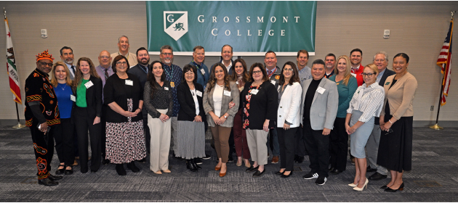
EAST COUNTY EDUCATION ALLIANCE
FOCUS PLAN 2025-2030
Introduction
The East County Education Alliance (the Alliance) has been working since 2014 to enrich the East County community through strong partnerships with local high school districts that guide students toward a world-class education, leading to social and economic mobility.
In response to the growing need for equitable access to higher education, the Alliance is intentionally shifting its focus toward advancing educational equity and opportunity, within the framework of Vision 2030, the California Community Colleges Chancellor’s Office’s (CCCCO) roadmap for transformational change that emphasizes equitable access, equitable success, and equitable support.
In alignment with Vision 2030 Goals, this updated plan outlines a strategic approach to supporting historically underserved students, expanding access to dual enrollment*, and guiding students from high school into college with a focus on career pathways and holistic student support. The new direction of the Alliance is built on a foundation of collaboration between the Grossmont-Cuyamaca Community College District, the Grossmont Union High School District, the Mountain Empire High School District, Helix Charter High School, and Steele Canyon Charter High School. It centers on nine key Action Steps that directly address barriers to higher education and economic mobility:
1. Foster early college exposure
2. Eliminate barriers to dual enrollment
3. Expand College and Career Access Pathways (CCAP)
4. Increase the number of high school graduates with college credit units 5. Enhance academic support
6. Establish career and college pathways
7. Expand college and career planning
8. Provide targeted support for underserved populations
9. Increase access to financial aid
By defining clear Action Steps and measurable key performance indicators (KPIs), this plan serves as a roadmap for achieving the Vision 2030 goals of preparing all students for success beyond high school. The work described here not only supports the Governor’s goal of 70% of adults earning a degree or certificate by 2030, but also reinforces the Alliance’s collective mission to create a more inclusive, streamlined, and supportive educational pipeline for every student.
*The State Chancellor’s office uses the term “dual enrollment” in Vision 2030. For the purpose of this plan, dual enrollment is the overarching umbrella of CCAP and concurrent enrollment (high school students taking classes on the college campuses).
8800 Grossmont College Drive, El Cajon, CA | 619-644-7010 | www.gcccd.edu
2
East County Education Alliance Focused Goals and Objectives 2025-2026 through 2029-2030
Focus Goal 1. Equity in Access
California Community Colleges’ Vision 2030 goal of Equity in Access strives to “Broaden the opportunities for all Californians to participate in higher education by starting or continuing their higher education at a California community college.” Ensuring that all high school students have early exposure to college and Career Technical Education (CTE) pathways through dual enrollment aligns with Vision 2030’s goal of Equity in Access.
The Alliance would focus on the following Action Steps:
1. Foster Early Exposure through Dual Enrollment
• Identify and train high school counselors on dual enrollment benefits and processes • Host informational sessions for students and families at middle and high schools
• Develop clear pathways for dual enrollment aligned with CTE high school pathways and college majors
• Emphasize early exposure to college by enrolling 9th grade students in college transfer, career, and/or apprenticeship pathways
2. Eliminate Enrollment Barriers for CCAP and Concurrent Enrollment
• Simplify and align enrollment processes between the K-12 schools and Grossmont and Cuyamaca colleges
• Improve Student Services coordination between colleges and high school partners
3. Expand College Career Access Pathways (CCAP)
• Increase the number of CCAP courses offered
• Increase the number of high school students enrolled in at least one CCAP course by 25%
• Expand outreach efforts for historically underrepresented students (i.e., low income students, first-generation college students, students with disabilities, foster youth, etc.)
• Offer CCAP courses to 9th grade students
• Pilot summer bridge programs for rising 11th grade and 12th grade students
8800 Grossmont College Drive, El Cajon, CA | 619-644-7010 | www.gcccd.edu
3
State Benchmark:
• By 2030, increase the number of students attending a California Community College (CCC) by either 25% or to pre-pandemic levels, whichever is greater
Performance Indicators:
• Number of CCAP sections offered
• Number of students enrolled in CCAP sections
• Percent of CCAP students disaggregated by historically underrepresented populations
• Number of 9th grade students enrolling in CCAP sections
• Number of CCAP sections specifically designed for 9th grade students
8800 Grossmont College Drive, El Cajon, CA | 619-644-7010 | www.gcccd.edu
4
Focus Plan Goal 2. Equity in Success
Under the goal of Equity in Success, Vision 2030 strives to “Ensure the academic and career success of all Californians who are current and prospective California community college students.” Ensuring the success and support of high school students who participate in dual enrollment aligns with Vision 2030’s goal of Equity in Success.
The Alliance would focus on the following Action Steps:
4. Increase, by 15%, the Number of High school Students Graduating with at least 12 Units of College Credit (statewide goal)
• Develop a sense of belonging to the GCCCD and community college culture among high school students
5. Enhance Academic Support
• Increase awareness of access to academic support, such as tutoring, and English and Math Centers at the colleges through dual-enrollment-specific marketing and communications
6. Establish College and Career Planning for Academic Pathways
• Establish at least one academic pathway at each site that begins in 9th grade for each high school
• Align student high school coursework with future academic and career goals, increasing completion likelihood through intentional academic pathways
• Increase the number of high school students graduating with a certificate of achievement or associate degree while in high school
State Benchmark:
• By 2030, increase the number of CCC students completing a certificate, associate degree, or baccalaureate degree by 30%
Performance Indicators:
• Course success rate for CCAP students disaggregated by historically underrepresented populations
• Number of high school students graduating with 12 or more units of college credits
• Number of students completing transfer-level English or math by high school graduation
• Number of students enrolling in college in the fall semester immediately following high school graduation
8800 Grossmont College Drive, El Cajon, CA | 619-644-7010 | www.gcccd.edu
5
Focus Goal 3. Equity in Support
Under the goal of Equity in Support, Vision 2030 strives to “Partner with other systems, agencies, institutions and community-based organizations to provide students the academic, financial and social supports necessary to thrive by taking education opportunities and the accompanying support to Californians.” Providing students with the essential tools, services, guidance, and safety net they need to stay on their college path aligns with Vision 2030’s goal of Equity in Support.
The Alliance would focus on the following Action Steps:
7. Expand College and Career Planning
• Ensure all CCAP students complete a college educational plan and a career assessment by offering counseling courses or providing information through orientations, workshops, and/or fairs
• Create webpages with available pathways and course offerings for each high school
8. Provide Targeted Support for Underserved Populations
• Build intentional support systems tailored to the needs of marginalized students by increasing awareness among dual enrolled students about college student support services such as Basic Needs, mental health services, foster youth services, and services for undocumented students
9. Increase Access to Financial Aid and College Application Support • Conduct financial aid application completion workshops at each partner site • Host College application boot camps for 12th grade dual enrollment participants
• Provide multi-language support for the completion of the Free Application for Federal Student Financial Aid (FAFSA) and/or the California Dream Act Application (CADAA)
State Benchmark:
• By 2030, increase the number of CCC students receiving Pell and CCPG by 10%
Performance Indicators:
• FAFSA/CADAA completion rate among 12th grade students
• College application submission rate by high school
• Attendance at financial aid and college application workshops
• Percent of CCAP students who received instruction on how to develop a college educational plan
• Percent of CCAP students who access support programs disaggregated by historically underrepresented populations
8800 Grossmont College Drive, El Cajon, CA | 619-644-7010 | www.gcccd.edu
6
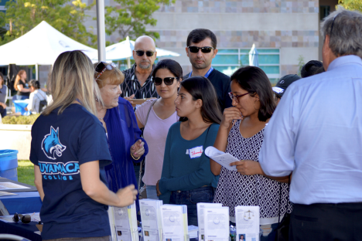
8800 Grossmont College Drive, El Cajon, CA 92020
619-644-7010 | www.gcccd.edu

