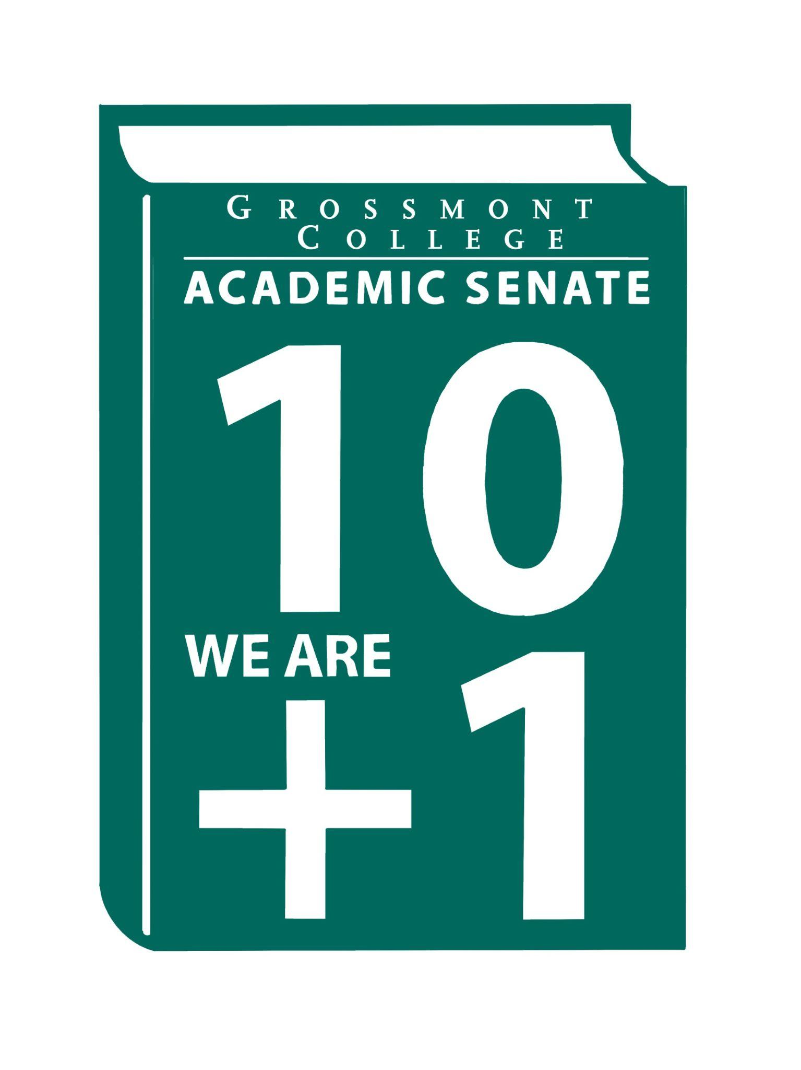  10 + 1  Title 5 §53200(b): Academic Senate means an organization whose primary function is to make recommendations with respect to academic and professional matters. In Sections 53200(c),  "Academic and professional matters" means the following policy development and implementation matters:  (1) curriculum, including establishing prerequisites and placing courses within disciplines;  (2) degree and certificate requirements;  (3) grading policies;  (4) educational program development;  (5) standards or policies regarding student preparation and success;  (6) district and college governance structures, as related to faculty roles;  (7) faculty roles and involvement in accreditation processes, including self-study and annual reports;  (8) policies for faculty professional development activities;  (9) processes for program review;  (10) processes for institutional planning and budget development; and  (11) other academic and professional matters as are mutually agreed upon between the governing board and the academic senate  District/College is to “rely primarily upon the advice and judgment”  (5 CCR 53200(d)) Of the A.S. in the following areas:  COLLEGE MISSION STATEMENT  MISSION  Grossmont College serves the diverse population of our surrounding community and beyond by creating clear and accessible pathways to degrees and careers that lead to social and economic mobility for our students. We work collaboratively to cultivate an equitable student-centered learning environment, and we hold ourselves accountable for improving student outcomes through ongoing assessment, evaluation, and data-informed decision-making. Grossmont.  PROCESSES FOR  COLLEGIAL CONSULTATION  (5 CCR 53200(d) & GCCCD AP 2510)  *The Board will Rely Primarily Upon  the Academic Senate  **The Board will seek Mutual  Agreement with the Academic Senate. |   Academic Senate Agenda  Monday, December 1, 2025  11:00 am–12:20 pm  Griffin Gate  ATTACHMENTS  - Call to Order - 11:00 AM  - Public Comment—Persons wishing to address the Senate will be given a maximum of 4 minutes to address the Senate about a non-agendized item or items, with a maximum of 15 minutes allowed for public comment. The Senate may vote to extend public comment at any meeting. If you wish to speak during public comment, please complete the attached form by Thursday, within 72 hours of the scheduled academic senate meeting. The Senate welcomes all speakers to participate in the discussion on agendized items.  - Approval of minutes (11/17/25) (2 min)  - Approval of Agenda (2 min)  - Announcements  5.1 ADSOC Agenda request (document in the attachment folder)  5.2 Faculty Hiring Committee-Volunteers needed (Child Development Faculty)  5.3 Child Development Center-Family Night  5.4 Joint AS Senate Retreat (Hosted @ Cuyamaca 1/29/26 10-12 pm)  5.5 Reassigned Timeline (Still pending review by the District led taskforce)  - President’s Report (10 min)  6.1 Feasibility Process (New Programs, Discontinuance, BDP)  - CSIS Update  - Respiratory Therapy Program  6.2 Sabbatical Applications (Updated Processing Timeline)  6.3 CCCCO guidance for implementing new Title 5 Regulations of the Flexible Calendar (Timeline- March 16th)  6.4 AI Taskforce-District Committee Update  6.5 Camera Signage on campus (Draft Protocol in the attachments)  7. Information Items: Updates and information are presented for discussion and feedback, including the introduction of items that will need constituency feedback and a vote of approval or endorsement at the next meeting.  7.1 Resolution Affirming 10+1 Primacy (2nd Read)  7.2 Revised Resolution (ASGC)- Ensuring Precalculus Choice at Grossmont College after AB 1705 (1st Read)  7.3 5.3.3.1 AFT Contract recommended language (Edits)  7.4 BP 4060 Delineation of Functions Agreements (Please Review)  BP 5070 Student Attendance Accounting Manual (Please Review)  8. Presentations  8.1 Faculty Representatives Reports  - Senate Committees  - Participatory Governance Committees  - Professional Advancement Committee (Submitted Written Report)  8.2 Chancellor’s Office on Safety & Security Policing Options  9. Action Items  9.1 Academic Senate One-Year Vision:  Statement of the year’s vision: fostering strong faculty voices, meaningful collaboration, responsive governance, and student-centered excellence.  10. Vice-President’s Report/Unfinished Business  10.1 Participatory Governance (open active recruitments)  10.2 Senators (Updating dept/division reps)  11. Future Agenda Items  11.1 Evan Wiring-CPL  11.2 Review of Bylaws  11.3 Review of Rules  12. ASCCC Webinars, Announcements, and Resources  - November 2025 Rostrum  - ASCCC Newsletter for November 7, 2025  - ASCCC Newsletter for November 20, 2025  - ASCCC Newsletter for October 23, 2025  - ASCCC OERI November 2025 Newsletter  - Academic Freedom Resource Guide is intended to support faculty with information to ensure they know their roles, rights, and responsibilities in the use of academic freedom; includes links to a Playlab.ai bot trained to support research on academic freedom  13. Adjournment – Next meeting 2/2/25

