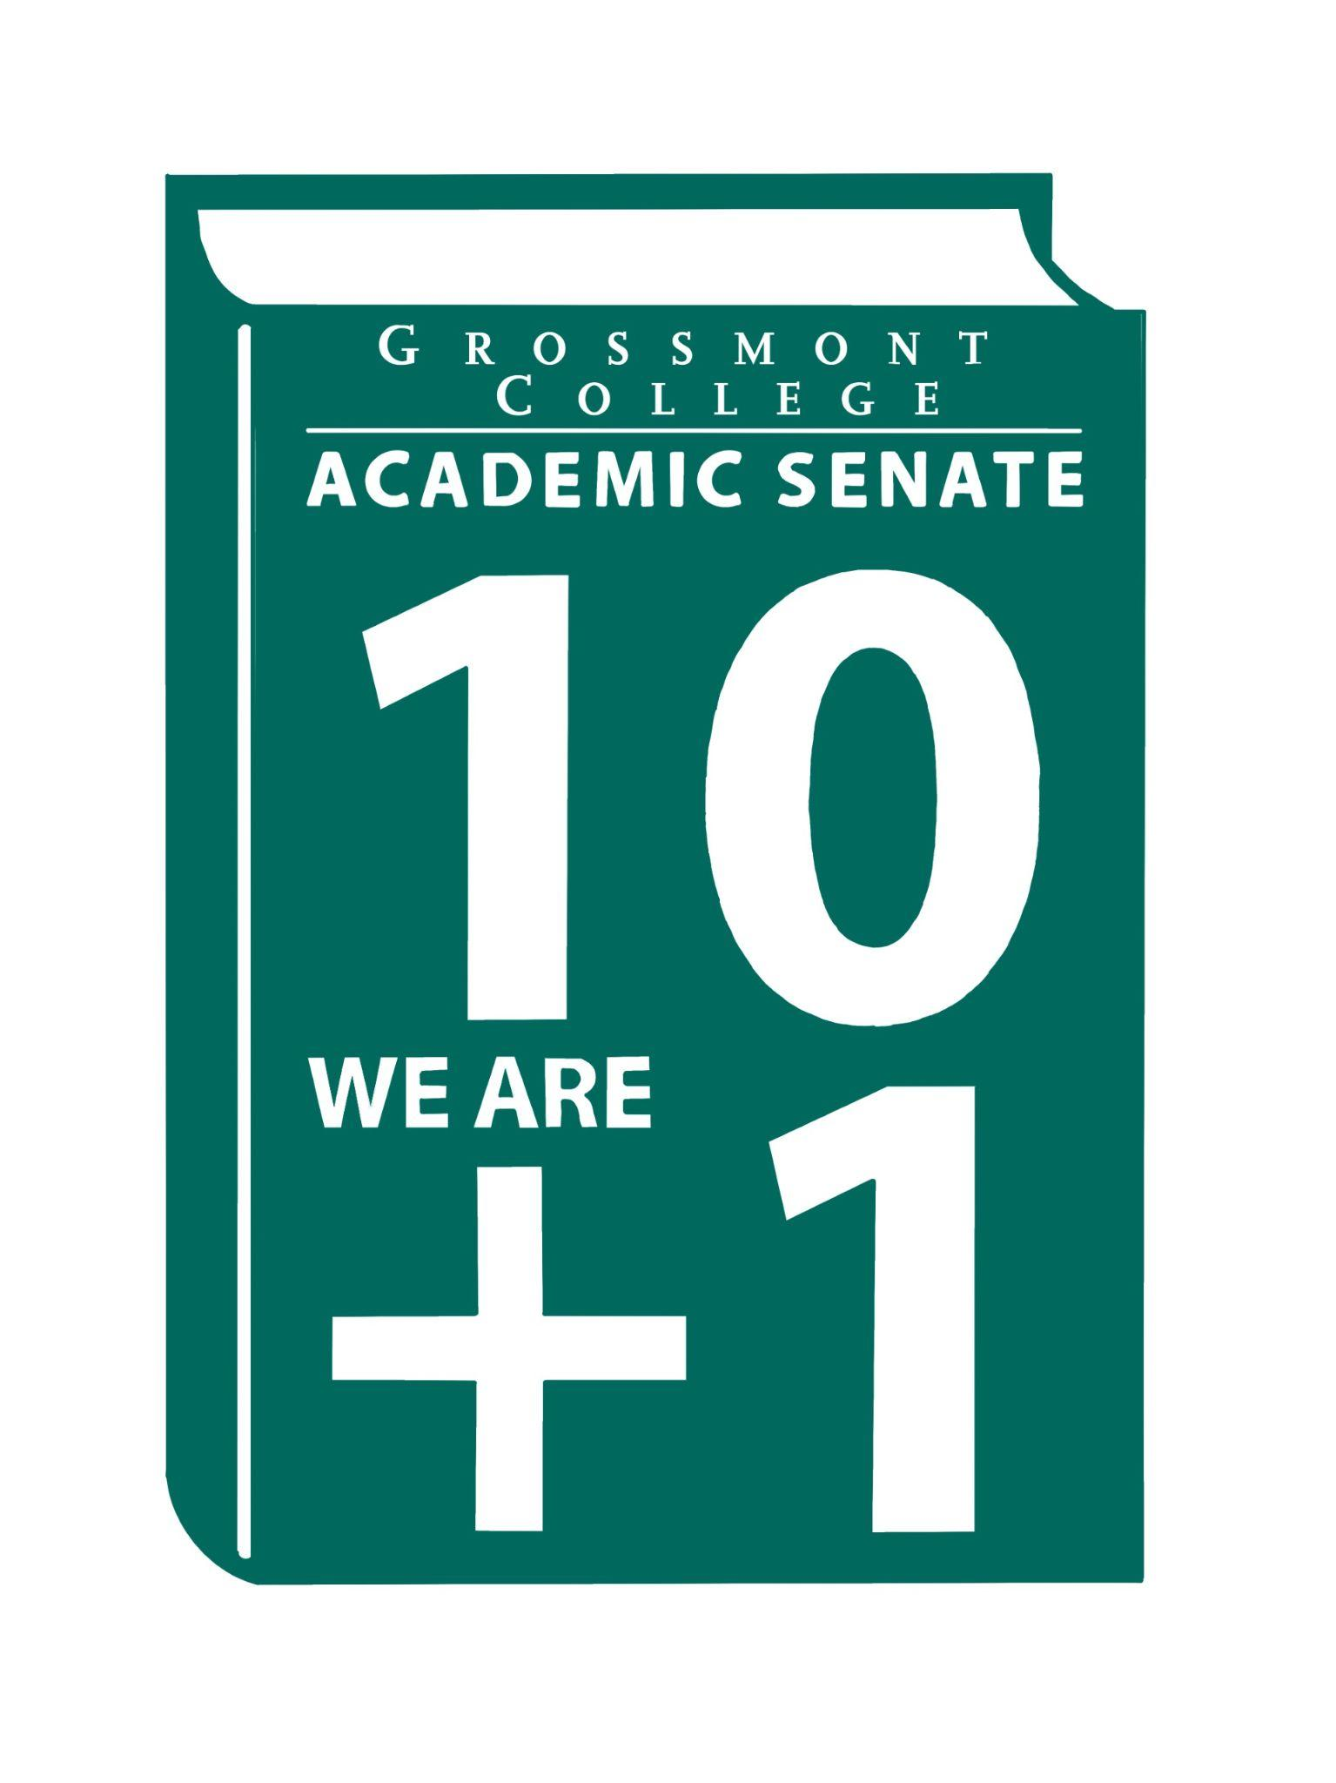  10 + 1  Title 5 §53200(b): Academic Senate means an organization whose primary function is to make recommendations with respect to academic and professional matters. In Sections 53200(c),  "Academic and professional matters" means the following policy development and implementation matters:  (1) curriculum, including establishing prerequisites and placing courses within disciplines;  (2) degree and certificate requirements;  (3) grading policies;  (4) educational program development;  (5) standards or policies regarding student preparation and success;  (6) district and college governance structures, as related to faculty roles;  (7) faculty roles and involvement in accreditation processes, including self-study and annual reports;  (8) policies for faculty professional development activities;  (9) processes for program review;  (10) processes for institutional planning and budget development; and  (11) other academic and professional matters as are mutually agreed upon between the governing board and the academic senate  District/College is to “rely primarily upon the advice and judgment”  (5 CCR 53200(d)) Of the A.S. in the following areas:  COLLEGE MISSION STATEMENT  MISSION  Grossmont College serves the diverse population of our surrounding community and beyond by creating clear and accessible pathways to degrees and careers that lead to social and economic mobility for our students. We work collaboratively to cultivate an equitable student-centered learning environment, and we hold ourselves accountable for improving student outcomes through ongoing assessment, evaluation, and data-informed decision-making. Grossmont.  PROCESSES FOR  COLLEGIAL CONSULTATION  (5 CCR 53200(d) & GCCCD AP 2510)  *The Board will Rely Primarily Upon  the Academic Senate  **The Board will seek Mutual  Agreement with the Academic Senate. |   Academic Senate Agenda  Monday, November 3, 2025  11:00 am–12:20 pm  Room 70-131  ATTACHMENTS  - Call to Order - 11:00 AM  - Public Comment—Persons wishing to address the Senate will be given a maximum of 4 minutes to address the Senate about a non-agendized item or items, with a maximum of 15 minutes allowed for public comment. The Senate may vote to extend public comment at any meeting. If you wish to speak during public comment, please complete the attached form by Thursday, within 72 hours of the scheduled academic senate meeting. The Senate welcomes all speakers to participate in the discussion on agendized items.  - Approval of minutes (10/20/25) (2 min)  - Approval of Agenda (2 min)  - Announcements  5.1 Reminder Support-Active Duty/Veterans Day Event (11/10/25)  5.2 Child Development Program (Family Night Support)  5.3 Basic Needs Resources (Supporting our students)  5.4 Academic Senate Google Site-Active with posted ASCCC Announcements  - President’s Report (10 min)  6.1 Human Resources Council Update (AP 2710)  6.2 Draft Academic Calendar 2027-2028  6.3 Modification of Faculty Prioritization Committee Proposal (Charge & Composition changes)  6.4 Student arrest on campus (Follow-up requested from College/District)  6.5 Renewing Discretionary Time (RT- delays)  7. Information Items: Updates and information are presented for discussion and feedback, including the introduction of items that will need constituency feedback and a vote of approval or endorsement at the next meeting.  7.1 Resolution Affirming 10+1 Primacy (1st Read)  7.2 AP/BP4021 Program Discontinuance (Please review for recommendations)  8. Presentations (Faculty Representatives Reports- Senate & Participatory Governance Committees)  9. Action Items  9.1 Faculty Protocol: Responding to Social Media Harassment and Threats Targeting Faculty on Academic Freedom  9.2 Academic Senate One-Year Vision:  Statement of the year’s vision: fostering strong faculty voices, meaningful collaboration, responsive governance, and student-centered excellence.  10. Vice-President’s Report/Unfinished Business  10.1 Participatory Governance (open active recruitments)  10.2 Senators (Updating dept/division reps)  11. Future Agenda Items  11.1 Board of Trustees Follow-up Requests  11.2 Evan Wiring & Michael Stewart-CPL  11.3 New/Newer Employee Welcome Reception  11.4 Robert Henry-History Department (Narrative & Remembrance)  12. Adjournment – Next meeting 11/17/25
  Participatory Governance Committees | Faculty Representatives | Senate Committees | Faculty Representative (Chair/Designee)
  Budget Committee | P. Lopez/ J.Bergovoy | Curriculum Committee Chair | D.Aceves
  College Council | S.Sampson/R. Unis/J.Wahler/ J.Yang | FPDC | E.Burke
  Facilities Committee Report | M. Bacon/R.Gray | OTLC | A.Roe/A.Feres
  PIEC Report | M.Molina/R.Akua | OER/ZTC | Z.Tethong
  Professional Development Report | Michael Kelley/Lucy Holland | Part-time Faculty | R.Unis
  Staffing Report | J.Yang/  A.DiDomenico | Program Review | J.Fries/K.Menck
  Faculty Staffing Prioritization Committee | A.Barkzi /L. Braff/B.Fitzgerald/R.Navarro/J.Silva/J. Yang
  SS&E Report | K.Macias/  S.Shamasha
  Classifies Staffing Prioritization Committee Report | N.Ray/D.Vance
  Technology Report | J.Czworkowski/ L.Parello

