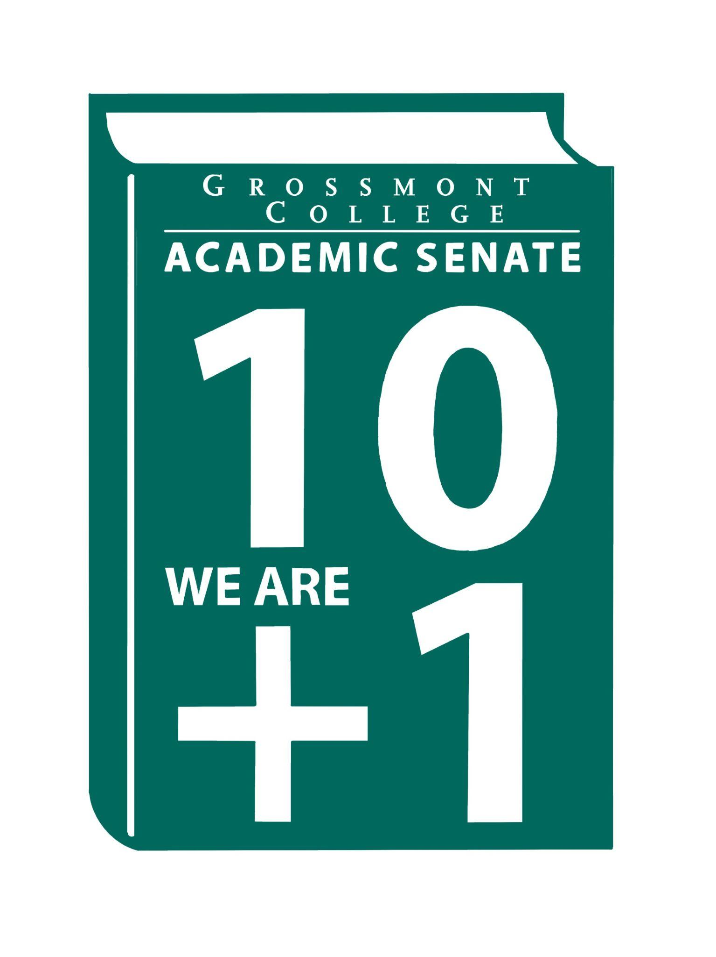  10 + 1  Title 5 §53200(b): Academic Senate means an organization whose primary function is to make recommendations with respect to academic and professional matters. In Sections 53200(c),  "Academic and professional matters" means the following policy development and implementation matters:  (1) curriculum, including establishing prerequisites and placing courses within disciplines;  (2) degree and certificate requirements;  (3) grading policies;  (4) educational program development;  (5) standards or policies regarding student preparation and success;  (6) district and college governance structures, as related to faculty roles;  (7) faculty roles and involvement in accreditation processes, including self-study and annual reports;  (8) policies for faculty professional development activities;  (9) processes for program review;  (10) processes for institutional planning and budget development; and  (11) other academic and professional matters as are mutually agreed upon between the governing board and the academic senate  District/College is to “rely primarily upon the advice and judgment”  (5 CCR 53200(d)) Of the A.S. in the following areas:  COLLEGE MISSION STATEMENT  MISSION  Grossmont College serves the diverse population of our surrounding community and beyond by creating clear and accessible pathways to degrees and careers that lead to social and economic mobility for our students. We work collaboratively to cultivate an equitable student-centered learning environment, and we hold ourselves accountable for improving student outcomes through ongoing assessment, evaluation, and data-informed decision-making. Grossmont.  PROCESSES FOR  COLLEGIAL CONSULTATION  (5 CCR 53200(d) & GCCCD AP 2510)  *The Board will Rely Primarily Upon  the Academic Senate  **The Board will seek Mutual  Agreement with the Academic Senate. |   Academic Senate Agenda  Monday, October 20, 2025  11:00 am–12:20 pm  Griffin Gate  ATTACHMENTS  - Call to Order - 11:00 AM  - Public Comment—Persons wishing to address the Senate will be given a maximum of 4 minutes to address the Senate about a non-agendized item or items, with a maximum of 15 minutes allowed for public comment. The Senate may vote to extend public comment at any meeting. If you wish to speak during public comment, please complete the attached form by Thursday, within 72 hours of the scheduled academic senate meeting. The Senate welcomes all speakers to participate in the discussion on agendized items.  - Approval of minutes (10/6/25) (2 min)  - Approval of Agenda (2 min)  - Announcements  5.1 Support/Active Duty/Veterans Day Event (11/10/25)  5.2 Area D Resolutions (ASCCC)  5.3 Facilities Equity (Basic Needs Relocating to the Bookstore)  5.4 AFT Know your Contract Mtg (10/16/25)  - President’s Report (10 min)  6.1 AP/BP (recommended language that includes “consultation with Academic Senate”)  6.2 Campus Safety Measures (Exploration of C-CERT Campus Community Emergency Response Teams)  6.3 Equitable Access to Food (Interim President & VPAS’s Exploration of Fresh Vending by Admin & Contract with local coffee shop owner)  6.4 Swapmeet coming to GC campus (VPAS is negotiating revenue generating income for facilities with owners of the Santee Swapmeet)  6.5 EEOAC-New HIRE Training  7. Information Items: Updates and information are presented for discussion and feedback, including the introduction of items that will need constituency feedback and a vote of approval or endorsement at the next meeting.  7.1 Protocol Workplace Violence-(Academic Freedom) (Revisiting)  7.2 AP 4105: Distance Education (Please review for recommendations)  8. Presentations  8.1 Karolia Macias & Dr. Victoria Rodriguez (Approval for 2025-2028 Student Equity Plan)  8.2 Tate Hurvitz-Student Printing Options Taskforce Update  8.3 June Yang- Team Teaching  8.4 Faculty Representatives Reports- Senate & Participatory Governance Committees  9. Action Items  9.1 Academic Senate Norms  9.2 Academic Senate One-Year Vision:  Statement of the year’s vision: fostering strong faculty voices, meaningful collaboration, responsive governance, and student-centered excellence.  9.3 MOU-National University  10. Vice-President’s Report/Unfinished Business  10.1 Participatory Governance (open active recruitments)  10.2 Senators (Updating dept/division reps)  11. Future Agenda Items  11.1 Board of Trustees Follow-up Requests  11.2 Invitation to the College Interim President  11.3 New/Newer Employee Welcome Reception  10. Adjournment – Next meeting 11/3/25 (Room Change to 70-131)

