- Predict the general features of the proton and C-13 NMR spectra of the following compounds. Use the format of question 2 below.
a) diethyl ketone

b) p-ethylbenzoic acid

c) CH₃-O-CH(CH₃)-CH₂-CH=O

- Identify the following compounds based on their proton NMR spectra:
a) C₃H₆O
2.72 ppm, area 2, quintet
4.73 ppm, area 4, triplet
b) C₈H₈O₂
11.0 ppm, area 1, singlet
7.0 ppm, area 5, multiplet
3.0 ppm, area 2, singlet

c) C₁₀H₁₄
7.05 ppm, area 4, singlet
2.45 ppm, area 4, quartet
1.05 ppm, area 6, triplet
d) C₃H₆Br₂
3.80 ppm, area 1, multiplet
3.50 ppm, area 2, doublet
1.12 ppm, area 3, doublet
e) C₆H₁₀
4.82 ppm, area 2, singlet
2.22 ppm, area 4, triplet
1.65 ppm, area 4, triplet

- Unknown. C₉H₁₂

  - Calculate the degrees of unsaturation
  - Make assignments in the IR and NMR spectrum. Be sure to draw structures and label with a,b,c, etc.

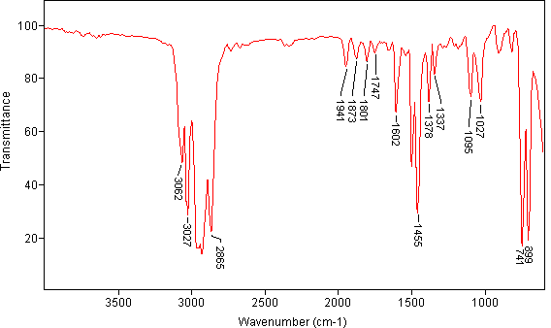

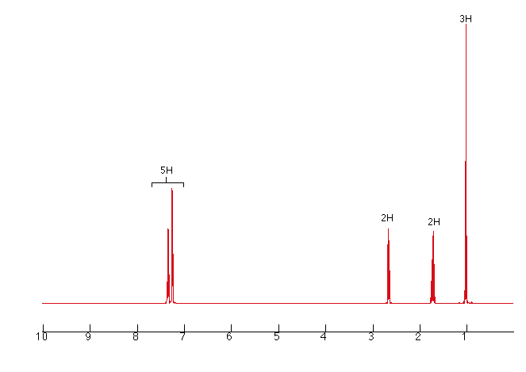

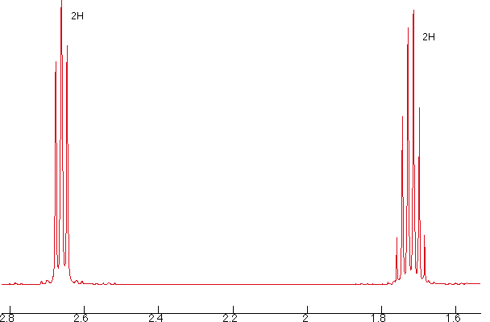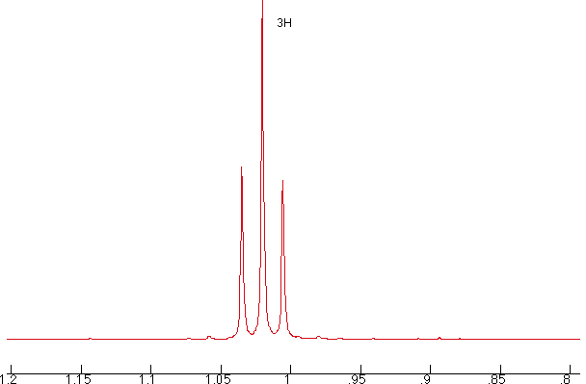

- Identify the unknown compound based on the data below. Molecular Formula is C₉H₁₂O .
Spectra are shown below and on the following page. Correlate spectral features with the structure.
H-NMR:
Areas of the peaks (left to right) are 5 : 3 : 1 : 1 : 2 .
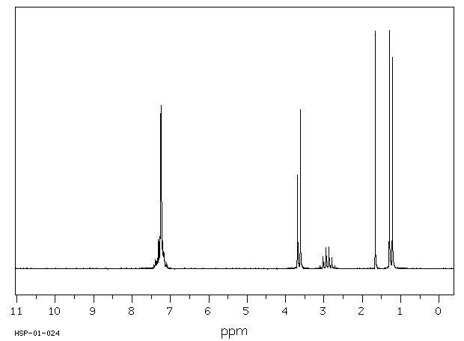
C-13 NMR:
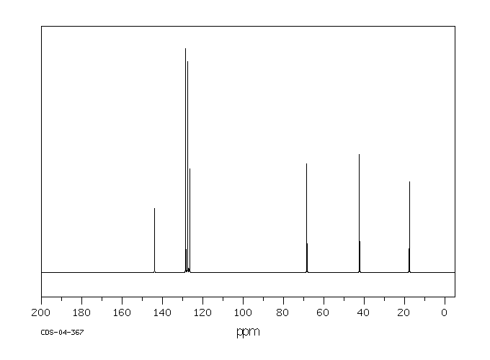

IR:
