Spring 2017 Exam 4A Chemistry 102 Name __
Multiple Choice (50 points)

Page 5 (31 points)

Page 6 (24 points)

Total (105 points)

Percent Grade ____________

Useful Information

Guanine Adenine Thymine cytosine Uracil
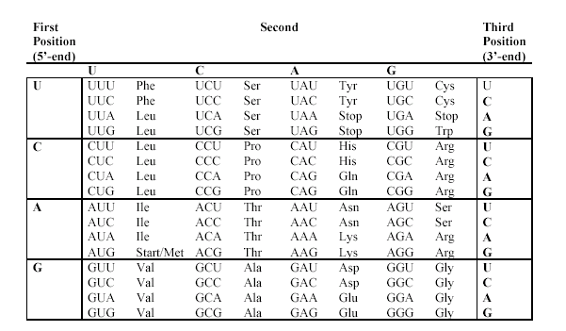

Multiple Choice

- If a covalent bond forms between an enzyme and an inhibitor the reaction catalyzed by this enzyme will have undergone ________.
- Irreversible inhibition | - Competitive inhibition | - Feedback control
- Noncompetitive inhibition | - Genetic control

- You are studying the effects of temperature on the rate of a particular enzyme-catalyzed reaction. When you increase the temperature from 40°C to 70°C, what effect will this have on the rate of the reaction?
- It will increase. | - It will decrease.
- It will decrease to zero because the enzyme denatures. | - It will increase and then decrease.
- This cannot be answered without more information.

- Which of the following amino acids is most likely to be found in the hydrophobic interior of a protein?
- Ser | - Phe | - Asn | - Gln | - Arg

- Which statement about amino acids is NOT correct?
- Naturally occurring amino acids are ‘L’ amino acids | - Amino acids in proteins are known as α-amino acids
- There are 20 common amino acids found in proteins. | - All are correct statements concerning amino acids

- The peptide bond in proteins is chemically the same as a ___________bond.
- ether | - amide | - alkene bond
- disulfide | - ester

- The isolectric point of an amino acid is the pH
- Equal to its pKa. | - At which it exists in acid form
- Which it exists in zwitterionic form. | - At which it exists in neutral form.
- At which it exists in basic form

- What type of bonding interaction occurs when two amino acid side chains, one containing a carboxyl group and the other an amino group, are in close proximity in the tertiary structure of a protein?
- a peptide bond | - an amide bond | - a disulfide bond
- a hydrophobic bond | - a salt bridge

- Which arrow below represents the reaction that would form the GA dinucleotide?

- 1 | - 2 | - 3
- 4 | - 5

- The tRNA anticodon:
- inhibits encoding of protein at a specific codon | - inhibits tRNA function
- provides feedback inhibition in the synthesis of tRNA | - binds selectively to a 3 base sequence in mRNA
- none of the above
- Which of the following types of RNA is paired with a correct piece of information about that type of RNA?
- tRNA; contains exons | - mRNA; contains codons
- rRNA; contains anticodons | - more than one correct response
- no correct response

- The sugar found in an RNA nucleotide is________.
- D-rhamnose | - D-ribose | - 2-deoxy-D-ribose
- D-raffinose | - all listed

- The regions of immature RNA which code the message for the protein synthesis is
- anti-codons | - introns | - replicons | - exons | - plasmids

- The sequence of a short DNA segment is ATGGCAATAC. What name do we give to the Adenine (A) end of the molecule?
- 5'-OH end | - 3'-OH end | - C-terminus
- N-terminus | - None listed

- The two strands forming the double helix of DNA:
  - have the same nucleotide composition, but run in opposite directions.
  - have complementary nucleotide compositions, running in the same direction.
  - are bound to one another by non-covalent hydrogen bonds.
  - are mirror images (enantiomers) of one another.
  - contain ribose, phosphate and either purines or pyrimidines.

- The backbone of a nucleic acid molecule consists of
  - Alternating nitrogen bases and phosphate groups linked by amide bonds and strengthened by hydrogen bonds.
  - Alternating sugar and phosphate groups linked by phosphate ester bonds.
  - Alternating sugar and nitrogen base groups linked by amide bonds.
  - Complementary bases joined by hydrogen bonds.
  - Sugar molecules bonded from the #3 carbon of one molecule to the #5 carbon of the other by glycosidic linkages.

- Which of the following nucleic acid base-pairs form the strongest bonding interactions in DNA?
- A-G | - T-C | - A-U
- G-C | - A-T

- Which statement concerning coenzymes and redox reactions is incorrect? Explain.
  - Oxidation can be considered as loss of hydrogen or gain of oxygen.
  - Reduction can be considered as gain of hydrogen or loss of oxygen.
  - NAD is the oxidized form of NADH.
  - An oxidation reaction cannot occur unless a reduction reaction also occurs.
  - FAD is the reduced form of FADH₂.

- In metabolism, CoA-SH usually reacts directly with
- ketones | - esters | - carboxylic acids | - alcohols | - water

- Which enzyme is involved in the conversion of phosphoenolpyruvate to pyruvate?
- enolase | - ketolase | - pyruvate kinase
- pyruvate oxidase | - None listed

- Which of the following statements correctly describe(s) catabolic pathways?
a. | They release energy as they degrade polymers to monomers.
b. | They consume energy to build up polymers from monomers.
c. | They do not depend on enzymes.
d. | They lead to the synthesis of catabolic compounds.
e. | both A and B

- Which of the following correctly describes citrate and isocitrate?
a. | they are both secondary alcohols
b. | they are both tertiary alcohols
c. | citrate is a secondary alcohol, but isocitrate is a tertiary alcohol
d. | citrate is a tertiary alcohol, but isocitrate is a secondary alcohol

- The steps of glycolysis between glyceraldehyde 3-phosphate and 3 phosphoglycerate involve all of the following except:
- ATP synthesis | - Catalysis by phosphoglycerate kinase | - Oxidation of NADH to NAD⁺
- Utilization of Pi. | - The formation of 1,3-bisphosphoglycerate

- Which of the enzymes or reactions listed below is MOST important in the reoxidation of NADH under anaerobic conditions?
  - Malate dehydrogenase
  - Lactate dehydrogenase
  - Conversion of glucose-6-phosphate --> fructose-6-phosphate
  - The conversion of isocitrate --> α-ketoglutarate
  - The conversion of oxaloacetate --> malate

- How many ATP molecules result from the “processing” of one acetyl CoA molecule through the common metabolic pathway?
- 24 | - 12 | - 8 | - 2 | - 36

- Carbon dioxide (CO2) is released during which of the following stages of cellular respiration?
- glycolysis and the oxidation of pyruvate to acetyl CoA
- fermentation and glycolysis
- the citric acid cycle and oxidative phosphorylation
- oxidative phosphorylation and fermentation
- oxidation of pyruvate to acetyl CoA and the citric acid cycle

Short answer

- (14 points) Some questions have more than one answer, so mark all that apply.
- primary structure | - secondary structure | - tertiary structure
- quaternary structure | - All of them.

- The interaction between the side chains of the amino acids in a protein or between proteins is found in this(these) structure(s). ___C D________

- Peptide bonds join the amino acids in the peptide chain. ____A___________

- Two polypeptide chains are held together with hydrogen bonds. ______D_________

- Hydrogen bonding between along the protein “backbone” that gives a coiled shape to the protein. ______B_____

- What level of protein structure is changed by an egg boiled in water for 10 minutes? _____B C D__________

- What level of protein structure is changed when acid is added to milk to make yogurt? ___ B C D _____

- What level of protein structure is changed when hydrolysis of a protein occurs? _______A________

- (8 points) Consider the following segment of mRNA:

AUG UGG AAC UGA

- What is the sequence of DNA that this strand of mRNA was transcribed from?

TAC ACC TTG ACT

- What will be the amino acid sequence? A mutation occurs that results in the replacement of the ninth nucleotide in the mRNA with U. What will be the result in the protein and why?

METHIONINE -TRYPTOPHAN - ASPARAGINE -- (STOP)
Substitution – silent mutation.
There was no effect on the protein coded by the gene, then the amino acid sequence was the same as the original sequence. Therefore the mutation resulting in a codon that encoded the same amino acid as the original amino acid due to the redundancy in the third position of the codon.
- (9 points) Explain the difference between the 3 sites on the ribosome (E, P, and A)?
Peptidyl (P) site – site on the ribosome where the polypeptide chain is built (amino acids link together)
Acceptor (A) site – site on the ribosome where tRNAs initially bind to the ribosome, matching their anti-codon to codons on mRNA, and bring the correct amino acid
Exit (E) site – site on the ribosome where empty tRNAs (without their amino acid) exit the ribosome

- (9 points) Consider the two reactions below. Which one is exothermic?
 | Reaction
A. | AcetylCoA + Oxaloacetate → citrate + CoASH + 8.0 kcal
B. | 7.5 kcal + Acetate + CoASH → AcetylCoA + H₂O

- Suppose the above two reactions were coupled. What does coupled mean?

Biochemical reactions that produce energy tend to be coupled to reactions requiring energy.

- What is the net result of these two reactions being coupled?
AcetylCoA + Oxaloacetate + Acetate + CoASH → citrate + CoASH + AcetylCoA + H₂O
COMPOUNDS THAT ARE ON BOTH SIDES OF THE ARROW CANCEL OUT
AcetylCoA + Oxaloacetate + Acetate + CoASH → citrate + CoASH + AcetylCoA + H₂O
Oxaloacetate + Acetate → citrate + H₂O
- Would the overall coupled reaction be endothermic or exothermic? Explain.
Exothermic: it release 0.5 kcal of energy
The energy released in step A is greater than the energy absorbed in step B

- (9 points) Where in the body does digestion of each take place and what enzyme(s) assist?
 | - polysaccharides | - triglycerides | - proteins
Location | Mouth and small intestine | Stomach, but mostly in the small intestine | Stomach and small intestine.
Enzyme(s) | Amylase | Lipase | Pepsin, Trypsin or dipeptidase
- (6 points) Given the following dipeptide

- Label the C and N terminus on the structure

- Complete the alkaline hydrolysis reaction of the following dipeptide by drawing the structures of the products as they would occur at high pH

Citric Acid Cycle
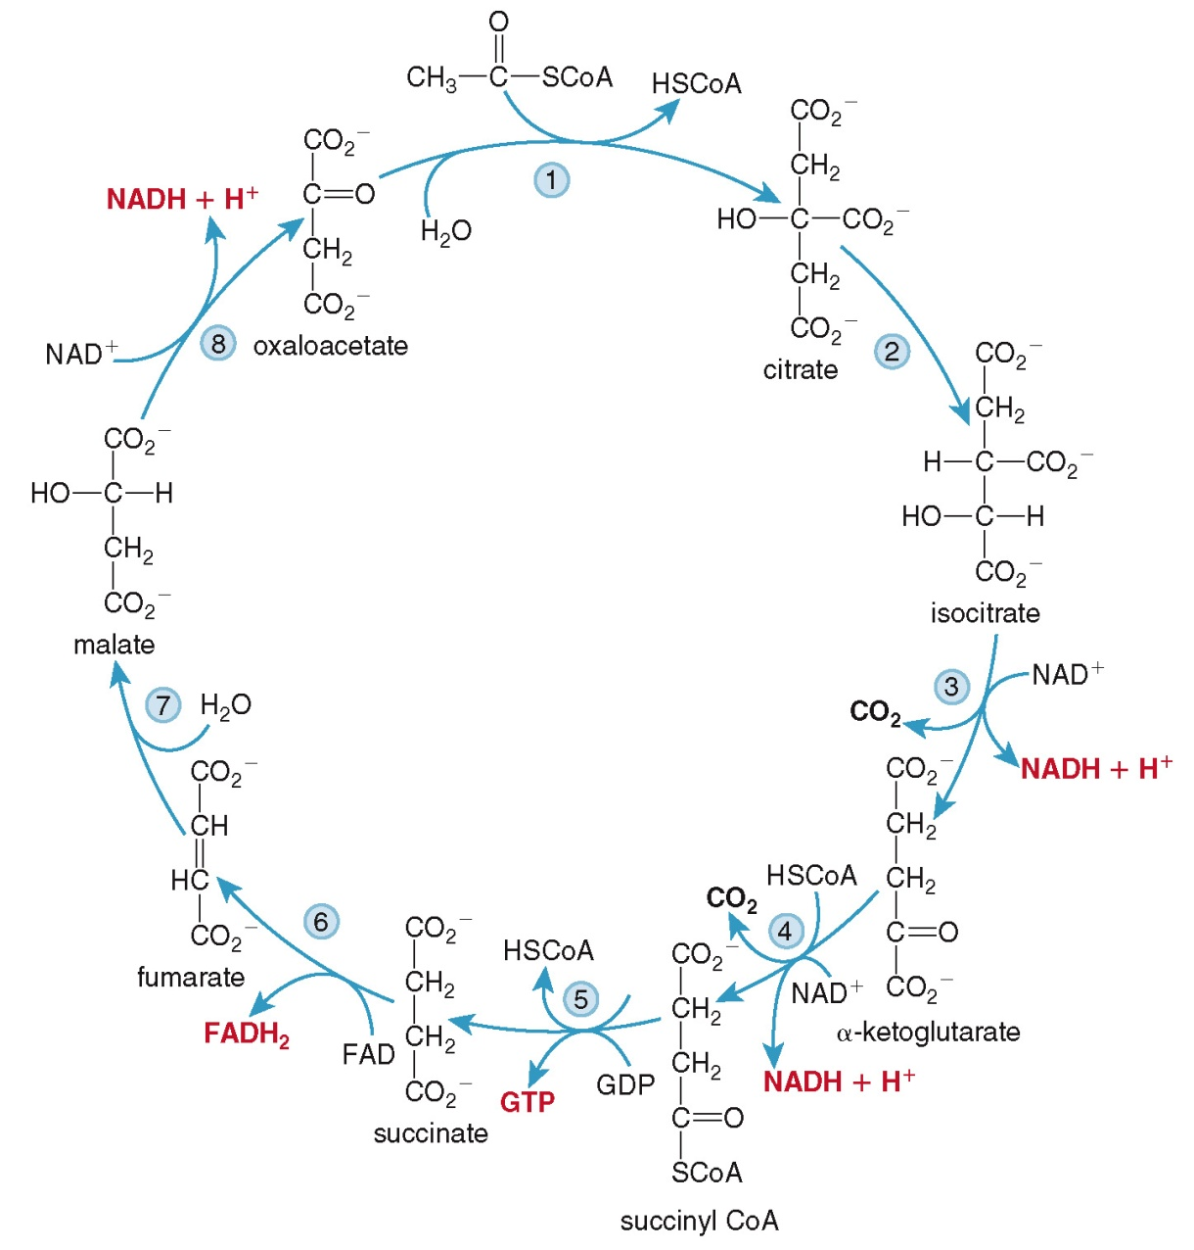

Glycolysis

