Grossmont College Name: ______________________
Chemistry 102, Spring 2017
Quiz 4A (21 points) Date: ____________

- (5 points) The potential energy diagram is for an ENDOTHERMIC / EXOTHERMIC reaction. (circle one)
Label the reactants, the products, activation energy (E_{act}), and change in energy (ΔE).

potential
energy

reaction progress

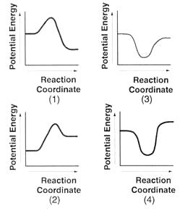

- (4 points) For each scenario below, state which factor (temperature change, change in amount, the presence of a catalyst) is being changed to alter the reaction rate.

- Firewood is chopped into small pieces to make lighting a fire easier. ______________________

- A black powder called manganese dioxide causes hydrogen peroxide to decompose faster than normal. The powder is not used up during the reaction.

______________________

- Food left in the fridge lasts longer than food left out. ______________________

- Coal dust can cause explosions. ______________________

- (4 points) Label the four functional groups on this molecule including acetals, hemiacetals

- (8 points) For each reaction, draw the expected product. For alkene addition pay attention to Markovnikov’s rule for unsymmetrical reagents.

