Exam 4A Name __
Multiple Choice (60 points)

Page 5 (24 points)

Page 6 (21 points)

Total (105 points)

Percent Grade ____________

Useful Information

Guanine Adenine Thymine cytosine Uracil
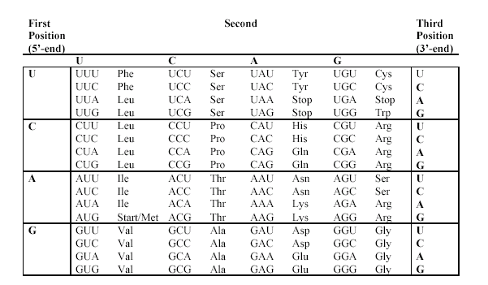

Multiple choice (2 points per question)

- Secondary structure of proteins, such as the α-helix, is attributed to:
- Hydrogen bonding between the amide groups on the "backbone."
- Hydrogen bonding between alcohols on R groups and amides on R groups.
- Covalent peptide bonds between amino acids.
- Salt bridges between charged R groups.
- Hydrophobic attractions of non-polar R groups.

- The enzyme catalase increases the rate at which hydrogen peroxide is broken down into water and oxygen gas. Catalase works by
- Increasing the amount of energy released in the reaction.
- Lowering the activation energy of the reaction.
- Decreasing how much product was formed during the reaction.
- Supplying energy to speed up the reaction.
- Changing the shape of the active site.

- The purine bases are
- 6 membered ring systems containing 2 ring nitrogens.
- 6 membered ring systems containing 4 ring nitrogens.
- Fused 5 and 6 membered ring systems containing 2 nitrogens.
- Fused 5 and 6 membered ring systems containing 4 ring nitrogens.
- None of the above

- Consider these two equations:
(1) Fructose 6-phosphate + HPO₄^{2–} Fructose 1,6-bisphosphate + H₂O
(2) ATP + H₂O ADP + HPO₄^{2–}

Which is the final equation for the coupled reaction?
- Fructose 1,6-bisphosphate + H₂O Fructose 6-phosphate + HPO₄^{2–}
- ADP + Fructose 1,6-bisphosphate ATP + Fructose 6-phosphate
- ATP + H₂O ADP + HPO₄^{2–}
- ADP + Fructose 6-phosphate ATP + Fructose 1,6-bisphosphate
- ATP + Fructose 6-phosphate ADP + Fructose 1,6-bisphosphate

- The statement “Enzymes are highly specific” means that certain
- Enzymes are found in certain cells.
- Reactions involving certain substrates are catalyzed by certain enzymes.
- Enzymes require certain concentrations of substrates.
- Reactions with certain activation energies are catalyzed by certain enzymes.
- Concentrations of substrates work with certain enzymes.

- The backbone of a nucleic acid molecule consists of
- Alternating nitrogen bases and phosphate groups linked by amide bonds and strengthened by hydrogen bonds.
- Alternating sugar and nitrogen base groups linked by amide bonds.
- Sugar molecules bonded from the #3 carbon of one molecule to the #5 carbon of the other by glycosidic linkages.
- Complementary bases joined by hydrogen bonds.
- Alternating sugar and phosphate groups linked by phosphate ester bonds

- NAD⁺ participates in reactions that produce
- ADP from ATP. | - A CH₂ group. | - A C—C bond.
- A C=O bond. | - Phosphorylation

- The anti-codon loop involved in translation is found in:
- the transcribed strand of DNA | - the introns of RNA | - the exons of RNA
- transfer RNA | - heterogeneous nuclear RNA

- Allosteric inhibitors act by
- Decreasing the amount of enzyme molecules.
- Increasing the amount of enzyme molecules.
- Decreasing the amount of the inactive form of the enzyme.
- Decreasing the amount of the active form of the enzyme.
- Increasing the amounts of substrate.

- Enzymes are highly sensitive to pH and temperature because
- Changes in the environment raise their activation energy.
- Changes in temperature and pH readily break their hydrogen bonds.
- Of their three-dimensional structure and side chains.
- At extreme temperatures and pH levels, coenzymes add chemical groups to the substrate.
- Extremes of temperature and pH level change the ionization rate.

- A kinase is an enzyme that:
- Adds water to a double bond.
- Uses FADH₂ to change the oxidation state of the substrate.
- uses ATP to add a phosphate group to the substrate
- removes phosphate groups off of substrates
- none of the above

- Some enzymes require small organic molecule, such as B vitamins, in order to have full activity. This component is called a:
- cofactor | - coenzyme | - regulator
- substrate | - donor groups

- Put the following translation events in order:
- elongation of the polypeptide
- base pairing of methionine-tRNA to AUG of the mRNA
- the larger ribosomal subunit binds to smaller ribosomal subunits
- peptide bonding between the first two amino acids
- the small subunit of the ribosome recognizes and attaches to mRNA

- i, ii, iii, iv, v | - v, iv, iii, ii, i | - v, iii, ii, i, iv
- v, ii, iv, i, iii | - v, ii, iii, iv, i

- Which of the following correctly describes citrate and isocitrate?
- Citrate is a tertiary alcohol, but isocitrate is a secondary alcohol
- Citrate is a secondary alcohol, but isocitrate is a tertiary alcohol
- They are both primary alcohols
- They are both secondary alcohols
- They are both tertiary alcohols

- Which of the following is correct about describing the induced fit model of an enzyme. Substrates fit into the active site:
- Because as the substrate and enzyme bind they both change shape to induce a better fit
- By changing their size and shape to match those of the active site
- By changing the size and shape of the enzyme
- Because both are exactly the same size and shape
- None of the above

- Enzymes are comprised of:
- Proteins | - Triacylglycerols | - Fatty acids
- Carbohydrates | - None of the above

- All of the statements about RNA are correct EXCEPT:
- RNA can exist in three forms: rRNA, tRNA, and mRNA.
- RNA does not contain thymine.
- RNA molecules are smaller than DNA molecules, but form double helices like DNA.
- Transfer RNA delivers amino acids to the protein chain as it is being manufactured.
All the statements are correct

- In the reaction in which succinate is converted to fumarate in the citric acid cycle, succinate undergoes a(n):
- isomerization | - hydration | - oxidation
- oxidative decarboxylation | - none of the above

- The substrate may be held in the active site of the enzyme (as the enzyme substrate complex) by
a) Ionic attraction | b) Hydrogen bonding | c). Hydrophobic attraction
d) All of them | e) None of them

- RNA splicing refers to
- Rejoining of broken mRNA transcripts
- Removal of introns and rejoining of exon sequences in mRNA
- Covalently attaching more than two RNA molecules into a star pattern
- Changing one base to another in the maturation of mRNA
- none of the above

- The products of glycolysis important in metabolism are
- CO₂and H₂O. | - acetyl-SCoA and ATP | - CO₂, ATP, and NADH
- pyruvate, ATP, and NADH | - pyruvate, ADP, and NAD+

- Examine the following structures A and B then
choose the best description:
- Structure A is a dinucleotide for RNA and
Structure B is a dinucleotide for DNA
b. Both A and B are DNA dinucleotides
c. Both A and B are RNA dinucleotides
d. none of the above

- What substance is produced by the oxidation of pyruvate and feeds into the citric acid cycle
- oxaloacetate | - glucose | - Acetyl CoA
- CO₂ | - O₂

- A nucleotide is composed of a ________ with a ________ added to it.

- nucleoside; nitrogen base | - phosphate group; nitrogen base
- nucleoside; phosphate group | - pentose; nitrogen base
- pentose; phosphate group

- Which term most precisely describes the cellular process of breaking down large molecules into smaller ones?
- Catalysis | - metabolism | - anabolism
- dehydration | - catabolism

- All of the following statements concerning digestion are correct except
- The major physical processes in digestion are mixing, softening and grinding of food.
- Different foods are digested by different enzymes.
- The major chemical reaction in digestion is enzyme-catalyzed hydrolysis of large molecules.
- Digestion can be considered a catabolic process in which bulk food is broken down into individual small molecules.
- Digestion begins in the stomach and is completed in the large intestine.

Next 5 questions, refer to the following answer choices for the listed descriptions:

- Primary protein structure | - Secondary protein structure | - Tertiary protein structure
- Quaternary protein structure | - All of the above

- Three-dimensional arrangement of every atom in a protein ________

- Sequence of amino acids ________

- Interaction of protein subunits ________

- Arrangement of protein chains into patterns ________

- Is not affected by denaturation ________

Problems

- (6 points) Please draw structure of Ala as a zwitterions and how will it look below and above pI.
Zwitterion | Below pI | Above pI

- (8 points) Draw the structure of Ala-Gly dipeptide at biological pH, showing the peptide linkage with an arrow. (label C-terminus, N-terminus)

- (8 points) Explain the following: using a drawing to illustration

- Illustrate how an enzyme normally works

- Illustrate how an enzyme works with a competitive inhibitor

- Explain how competitive inhibition can be reversed

- (8 points) First Transcribe from DNA, then translate the resulting mRNA (assume no introns):

DNA: 3’- TAC AAA ATA CAT ATT-5’

mRNA:

protein:

- (9 points) List the three major types of RNA and their functions.

- (4 points) Circle the high energy molecule within the pair

FAD or FADH₂
NADH or NAD⁺
ADP or ATP
CoA or AcCoA

Citric Acid Cycle
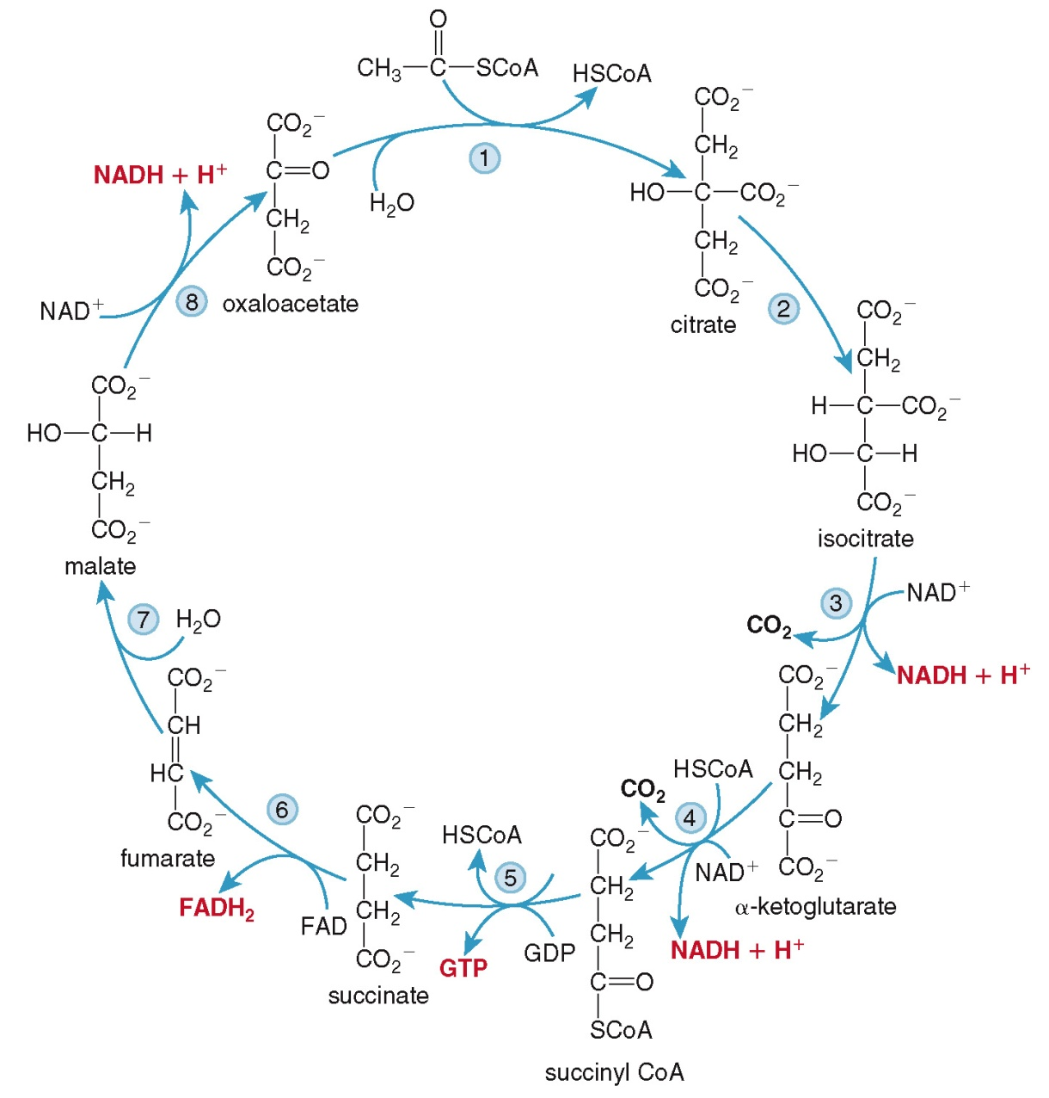

Glycolysis

