DNA/RNA worksheet
- What are nucleic acids? Why are they important?

- What are the two types of nucleic acids, and what are their main differences?

- DNA and RNA occur as polymers. What is their monomer called? What are the three components of this monomer and draw the general structure.

- Why do you think nucleotides are also sometimes referred to as “bases” or “nucleotide bases”?

- What is the difference between a nucleotide and a nucleoside? Explain by giving an example, using structures.

- Do the following:
- Name this structure below. Clearly box and label the nitrogenous base
- Clearly circle and label the sugar.
- Label the 5’ and 3’ end of the molecule.
- Indicate with a star what part of the molecule allows the two strands of DNA to be held together.

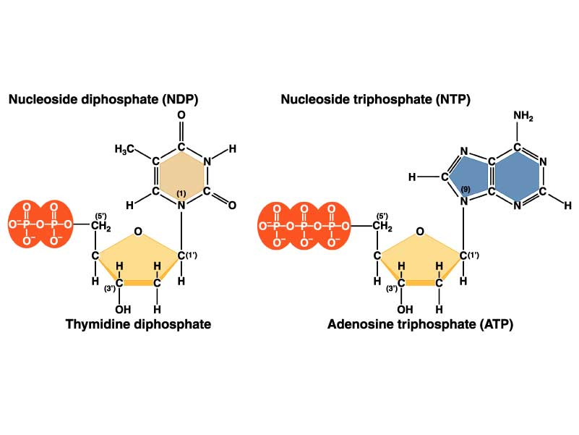

- What is the name and location of the kind of bond that links a sugar to a phosphate group in the primary structure of nucleic acids (polymerization of nucleotides)?

- What kinds of forces hold the double strands of a DNA double helix together? Do the two strands go in the same direction or in opposite directions?

- Three types of RNA involved in comprising the structural and functional core for protein synthesis, serving as a template for translation, and transporting amino acid, Define each type

- What is a codon? What is an anti-codon?

- What codon(s) signal the start and stop of protein synthesis?

- What are introns and exons?

- Define transcription and translation. Which process occurs first in order to make protein from DNA?

- In one sentence, explain what tRNA does.

- What is the mRNA, and what is the amino acid sequence for the following DNA strand?

TACCAGGCTGTTACT

- The following is a single strand of DNA: 3’ TACACACAAACGGGG 5’. Write the following in the space provided.

- Complementary DNA strand:

- mRNA:

- amino acid sequence:

